

**Online SHOES SHop**

**Software Requirement Specification**

– Hanoi, May 2023

–

Record of changeS

|  |  |  |  |
| --- | --- | --- | --- |
| Date | A* M, D | In charge | Change Description |
| 16/5 | A | ManhDD | Overview |
| 21/5 | M | ManhDD | Introduction, Screen Flow, ERD, User Authorization |
|  |  |  |  |
|  |  |  |  |
|  |  |  |  |
|  |  |  |  |
|  |  |  |  |
|  |  |  |  |
|  |  |  |  |
|  |  |  |  |
|  |  |  |  |

*A - Added

*M - Modified

*D - Deleted

Table of Contents

I. Overview 5

1.1. Introduction 5

1.2. System Functions 6

1.3. Entity Relationship Diagram 19

II. Functional Requirements 24

2.1. 19

2.2. 20

2.3 21

2.4. 22

2.5 24

2.6 25

2.7 27

2.8 29

2.9 30

2.10 31

2.11 32

2.12 33

# I. Overview

## 1.1. Introduction

Welcome to our student project, an online shoe store website. Our aim is to create a user-friendly platform for selling shoes online.

Our website will offer a diverse selection of shoes from local brands, catering to various fashion preferences. We will incorporate features such as user registration, product search, detailed descriptions, and a secure checkout process.

As a student-led project, we prioritize learning and applying industry best practices in software development. Through regular testing and user feedback, we will continually enhance the website's functionality and usability.

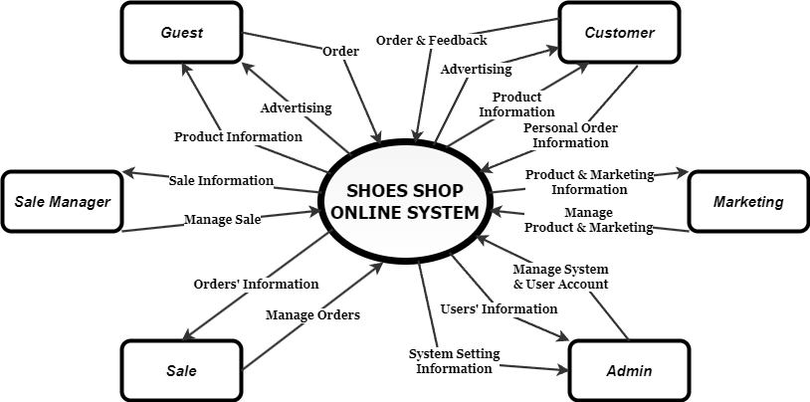

*Figure 1.1: Contact Diagram*

**• Guest:** Unregistered users  
**• Customer:** They are registered users who are actual customers or potential customers  
• **Marketing:** The marketing members of the organization  
**• Sale:** The sale members of the organization  
**• Sale Manager:** The sale manager in the organization  
• **Admin:** The organization leader/manager, acts as the system administrator

## 1.2. System Functions

#### a. Screen Flow

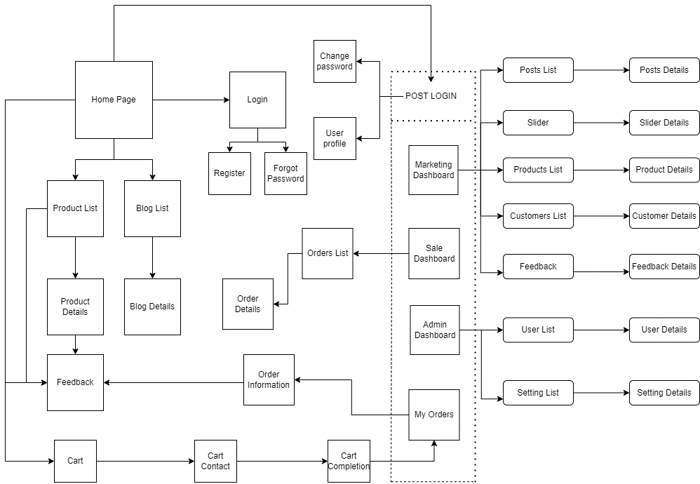

*Figure 1.2.a: Screen Flow Diagram*

#### b. Screen Details

|  |  |  |  |
| --- | --- | --- | --- |
| **#** | **Feature** | **Screen** | **Description** |
| 1 | Public | Home Page | Show sliders, hot posts, featured products + the slider with the latest posts, static contacts/links  - Shown slider information includes its image and title; the user is redirected to the slider's backlink on his/her clicking  - Shown post information includes its thumbnail, title, brief-info; the user is redirected to the post's details on his/her clicking  - Shown product information includes its thumbnail, title, brief information; the user is redirected to the product's details on his/her clicking |
| 2 | Public | Blogs List | Show the posts paginatedly (sorted by updated date, paginated) + the sider with the post search box, post categories, the latest posts, and static contacts/links; Shown post information includes its thumbnail, title, brief-info; the user is redirected to the post's details on his/her clicking |
| 3 | Public | Blog Details | Show post details (including title, author, updated date, category, and post details) + the sider with the post search box, post categories, static contacts/links |
| 4 | Public | Products List | Show the products paginatedly (sorted by updated date) + the sider with the product search box, product categories, the latest products, and static contacts/links;  - Shown product information includes its thumbnail, title, brief information, original price, and sale price;  - The user is redirected to the product's details on his/her clicking on the product  - The user can choose to add the product to the cart or to feedback on the product by clicking the product's Buy & Feedback buttons responsively |
| 5 | Public | Product Details | Show product details (including title, category, images, original price, sale price, and product details) + the sider with the product search box, product categories, the latest products, and static contacts/links |
| 6 | Public | Cart Details | Show the cart details with list of the user's chosen products (including Id, title, price, quantity, total cost) and the total order price + the sider with the product search box, product categories, the latest products, and static contacts/links; The user can  - Change the quantity of each product: the total cost is automatically adjusted  - Choose to delete/remove product by clicking on the deleting icon  - Click the Choose More Product button to go to Products List page  - Click the Check Out button to go to the Cart Contact page  Please notes: the user's chosen products from the last browsing session are remained in his/her cart until s/he submit the cart. However, the product prices are updated with the latest prices in the system |
| 7 | Public | Cart Contact | Show the list of user chosen product (including id, title, price, quantity, total cost), the total order price and the receiver information (including full-name, gender, email, mobile, address, notes) for user to edit/input + the sider with the product search box, product categories, the latest products, and static contacts/links  - In case the user has logged in, the receiver information would be filled with the user's information  - The user can click the Change button to come back to the Cart Details page for changing the choosing products, click the Submit button to submit the order before redirecting user to the Card Completion or Error page (due to technical error or any out-of-stock product) |
| 8 | Public | Cart Completion | This page show the cart completion notes + the sider with the product search box, product categories, the latest products, and static contacts/links; Before this page is shown:  - The Order status is changed to submitted;  - The product's available quantities are updated accordingly  - The submitted order is assigned automatically to the active salers rotatedly  - If the receiver information (name, email, mobile, gender) is new or changed (checking via the email0, the latest receiver information is stored in the system as latest & historical system contact information (for the marketing's reference later)  - The customer/user would be received the order confirmation & payment guides via his/her email. Those information is shown on the page also. The payment information (banking account,...) are taken from the system configuration file |
| 9 | Public | Feedback | On receiving the bought products successfully, the receiver would receive a confirmation email with the guides to feedback on each of the received product; Beside, the user/receive could also give the feedback (on a specific product or general feedback) via the website; The user also call this screen from the system menu on the header;  The feedback information includes contact information (full name, gender, email, mobile), rated star, the attached images and the contact's free-format feedback  The page sider is also shown with the product search box, product categories, static contacts/links; |
| 10 | Common | User Login | This is a pop-up screen which allows the user to enter email & password to login; on this page, there are also options for user to register new information or reset the password for the case s/he forget it |
| 11 | Common | User Register | This is a pop-up screen which allows the user to register himself/herself to the system by inputing following information: full name, gender, email, mobile, and address; User then need to verify by clicking the link sent via email to him/her before being able to access the system |
| 12 | Common | Reset Password | The user to input his/her email to receive the reset password link. This link is sent to the user's email for his/her password resetting.  - On clicking the link, the user is redirected to the password resetting page in which s/he input new password (twice) for the system access  - Note that the link is only available for a specific time duration as configured in the system config file. |
| 13 | Common | Change Password | This is a pop-up screen which allows the user to change his/her password by inputting his current password as well as new password (twice) |
| 14 | Common | User Profile | This is a pop-up screen which allows the user to edit his/her profile information, including the registered ones & the avatar image. Please note that s/he is not allowed to change the email |
| 15 | Common | User Authorization | Implementation of authorization mechanism in the system, including the specify the role of logged-in user, his/her authorized page links (building the displayed menu items (in the front end) and preventing unauthorized access via enter the links directly) |
| 16 | Customer | My Orders | Show the list of user's orders paginatedly + the sider with the product search box, product categories, the latest products, and static contacts/links  - Each order include below information: id, ordered date, product (first product name & number of other products if any), total cost, status;  - On clicking the link under the order id, user would be redirected to the Order Information page |
| 17 | Customer | Order Information | Show the order details, including the information as below + the sider with the product search box, product categories, the latest products, and static contacts/links  - The order id, order date, total cost, status  - The receiver information: full name, gendar, email, mobile  - This list of ordered products, each product include following information & the links/buttons that allow the user to re-buy or feedback: thumbnail, name, category, unit price, quantity, total cost  For the submitted orders, the user can choose to update (redirect the user to the Cart Details page for that) or cancel the order |
| 18 | Marketing | Posts List | Show the paginated list of posts (include posts' id, thumbnail, title, category, author, featured, and status information):  - The user can filter the post by category, author, status or search by title  - Sortable by title, category, author, featured, or status  - From each post, the user can choose to hide, show, view, edit it  - The page also have the button/link that allows the user to add new post |
| 19 | Marketing | Post Details | Show detailed post information (thumbnail, category, title, brief information,  description, flag to turn the featurning on/off, status), from that allow the user to input, view or edit them |
| 20 | Marketing | Sliders List | Show the paginated list of sliders (including sliders' id, title, image, backlink, status)  - The user can filter the sliders by the status + search by title or backlink  - For each slider, the user can choose to hide, show, edit it |
| 21 | Marketing | Slider Details | Show detailed slider information (image, title, backlink, status, notes) |
| 22 | Marketing | Products List | Show the paginated list of products (include products' id, thumbnail, title, category, list price, sale price, featured, and status information):  - The user can filter the product by category, status or search by title, brief info  - Sortable by title, category, list price, sale price, featured, or status  - From each product, the user can choose to hide, show, view, edit it  - The page also have the button/link that allows the user to add new product |
| 23 | Marketing | Product Details | Show detailed product information (thumbnail, category, title, brief information, attached images, description, quantity, list price, sale price, flag to turn the featurning on/off, status), from that allow the user to input, view or edit them |
| 24 | Marketing | Customers List | Show the list of customers / contacts paginatedly (include contacts' id, full name, gender, email, mobile, status):  - The user can filter the customers by status + search by full name, email, mobile  - Sortable by full name, email, mobile, status  - From each customer, the user can choose to add new, view or edit it |
| 25 | Marketing | Customer Details | Show detailed customer/contact information (full name, gender, email, mobile, address, status), from that allow the user to input, view or edit them (excep for the status which is generated automatically - contact, potential or customer)  Besides, the screen also shows the list of customer/contact changes history in the form of a table which includes following columns: email, full-name, gender, mobile, address, updated by, updated date |
| 26 | Marketing | Feedbacks List | Show the list of feedbacks paginatedly (include feedbacks' contact full name, product name, rated star, status):  - The user can filter the feedbacks by status, product, rated star + search by full name, feedback content  - Sortable by full name, product name, rated star, status  - From each feedback, the user can choose to view or change it's status |
| 27 | Marketing | Feedback Details | Show the feedback details (contact full name, email, mobile, product, rated star, feedback, images status) from that allow the user to change its status |
| 28 | Sale | Orders List | Show the list of orders paginatedly  - The list can be shorted by the order date, customer name, total cost, status  - Each order include below information: id, ordered date, customer name, product (first product name & number of other products if any), total cost, status;  - Allow the users to filter the order by the order date (from, to), sale name, status  - Allow the user to search the orders by order id, customer name  - On clicking the link under the order id, user would be redirected to the Order Details page |
| 29 | Sale | Order Details | Show the order details, including the following information:  - Basic order information: order id, customer full name, email, mobile, order date, total cost, sale name, status  - The receiver information: full name, gendar, email, mobile, address  - This list of ordered products, each product include following information: thumbnail, name, category, unit price, quantity, total cost  Sale Manager & the assigned Sale can change the order status & the sale notes  Sale Manager can assign the order to other sale |
| 30 | Sale | Sale Dashboard | 'Show the trend of success/total orders, and the revenues trends by day for the last 7 days for all or a specific sale person (the start date, end date, sale, order status can be adjustable) |
| 31 | Admin | Admin Dashboard | Show statistics of new orders (success, cancelled, submitted), revenues (total, by product categories), customers (newly registered, newly bought), feedbacks (average star: total, by product categories) & the trend of order counts (success, all) by day for the last 7 days (the start date & end date can be adjustable) |
| 32 | Admin | Users List | Show the paginated list of registered users (include users' id, full name, gender, email, mobile, role, status):  - The admin can filter the users by gender, role, status  - Allow the admin to seach users by full name, email, mobile  - The list is sortable by id, fullname, gender, email, mobile, role, status  - From each user, the admin can choose to view or edit it  - The page also have the button/link that allows the admin to add new user |
| 33 | Admin | User Details | Show detailed user information (avatar, full name, gender, email, mobile, role, address, status), from that allow the user to add new, view or edit user information  - After adding, new generated login password would be email to the new user  - The admin can only edit/update the role and status of the user |
| 34 | Admin | Settings List | Show the paginated list of settings (include settings' id, type, value, order, status):  - The admin can filter the setting by type, status  - Allow the admin to seach settings by value  - The list is sortable by id, type, value, order, status  - From each setting, the admin can choose to view, activate/deactivate, or edit it  - The page also have the button/link that allows the admin to add new setting |
| 35 | Admin | Setting Details | Show detailed user information (type, value, order, description, status), from that allow the user to add new, view or edit setting information |

*Table 1.2.b: Screen Details Table*

**c. User Authorization**

| **Screen** | **Admin** | **Guest** | **Customer** | **Marketing** | **Sale** | **Sale Manager** |
| --- | --- | --- | --- | --- | --- | --- |
| Home Page | x | x | x | x | x | x |
| Blogs List | x | x | x | x | x | x |
| Blog Details | x | x | x | x | x | x |
| Products List (Public) | x | x | x | x | x | x |
| Product Details (Public) | x | x | x | x | x | x |
| Cart Details |  |  | x |  |  |  |
| Cart Contact |  |  | x |  |  |  |
| Cart Completion |  |  | x |  |  |  |
| Feedback |  |  | x |  |  |  |
| User Login |  | x |  |  |  |  |
| User Register |  | x |  |  |  |  |
| Reset Password |  | x |  |  |  |  |
| Change Password | x |  | x | x | x | x |
| User Profile | x |  | x | x | x | x |
| My Orders |  |  | x |  |  |  |
| Order Information |  |  | x |  |  |  |
| MKT Dashboard |  |  |  | x |  |  |
| Posts List |  |  |  | x |  |  |
| Post Details |  |  |  | x |  |  |
| Sliders List |  |  |  | x |  |  |
| Slider Details |  |  |  | x |  |  |
| Products List (Marketing) |  |  |  | x |  |  |
| Product Details (Marketing) |  |  |  | x |  |  |
| Customers List |  |  |  | x |  |  |
| Customer Details |  |  |  | x |  |  |
| Feedbacks List |  |  |  | x |  |  |
| Feedback Details |  |  |  | x |  |  |
| Sale Dashboard |  |  |  |  | x | x |
| Sale Orders List |  |  |  |  | x | x |
| Sale Order Details |  |  |  |  | x | x |
| Admin Dashboard | x |  |  |  |  |  |
| Users List | x |  |  |  |  |  |
| User Details | x |  |  |  |  |  |
| Settings List | x |  |  |  |  |  |
| Setting Details | x |  |  |  |  |  |

*Table 1.2.c: User Authorization Table*

In which:

* Admin: the organization leader/manager, acts as the system administrator
* Guest: unregistered users
* Customer: they are registered users who are actual customers or potential customers
* Marketing: the marketing members of the organization
* Sale: the sale members of the organization
* Sale Manager: the sale manager in the organization

#### d. Non-Screen Functions

|  |  |  |  |
| --- | --- | --- | --- |
| **#** | **Feature** | **System Function** | **Description** |
| 1 | Common | Sign out | Users sign out of the system |
| 2 | Common | User Authorization | Authorize user into the system functions based on his/her role |

*Table 1.2.d: Non-Screen Functions Table:*

## 1.3. Entity Relationship Diagram

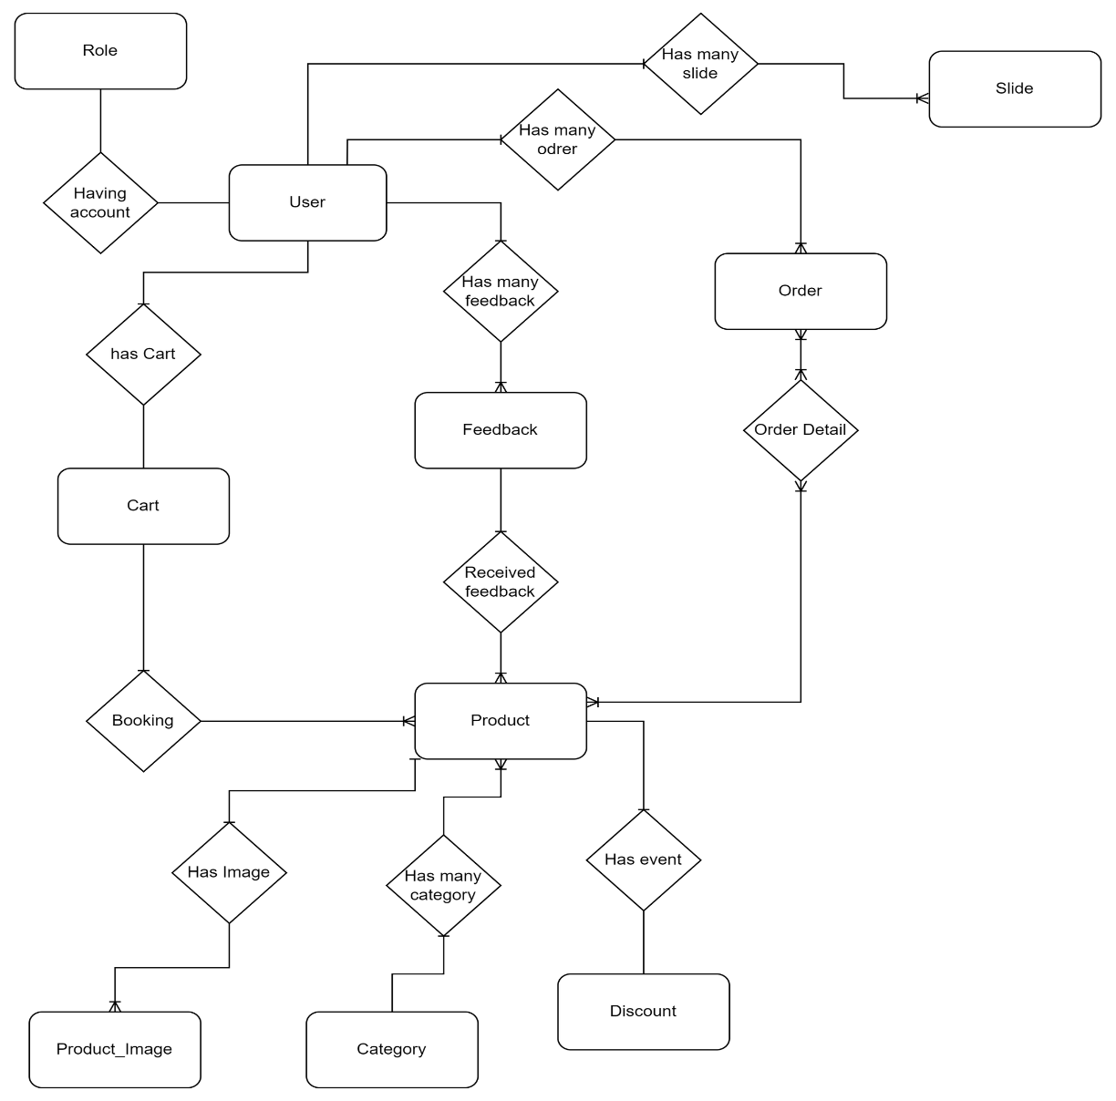

*Figure 1.3: Entity Relation Diagram*

**Entities Description**

|  |  |  |
| --- | --- | --- |
| **#** | **Entity** | **Description** |
| 1 | User | User Id: Id of User  Full Name: Name of user  Email: The account of the person who owns the account.  Address : The adderes of user  Avatar: The image of the user information  Mobile: The number phone contact with user  Password: The password of the person who owns the account.  RoleID: Used to determine the user's function in the online shopping website (0 Admin, 1 Sale Manager , 2 Sale, 3 Marketting, 4 Guest, 5 Customer).  Status: The status of the account (1: Active,2: Banned).  DOB: the date of birth of the user  Status: |
| 2 | Role | Role id: Id of user  Role Name : Name of role  Status: |
| 3 | Feedback | Feedback (Entity): Customers' comments on the products available in the store.  Feedback_ID: Used to identify the comment record in the Feedback table.  Product_ID: ID of the product that the customer comments on in the Products table.  AccountID: ID of the account that comments in the Accounts table.  Status: The status of the comment (1: Active, 2: Delete).  Date : The time the user posted this comment.  Status : The user's comment on the product.  Image: The picture that the user posts. |
| 5 | Products | Products (Entity): Products sold on the online shopping website  ProductID: Used to identify the product record in the Products table  ProductName: The name of the product  Picture: The picture describing the product  Price: The product's price (Take the lowest product price in the ProductDetails table). |
| 6 | ProductDetails | ProductDetailsID: Used to identify the product detail record in the ProductDetails table  ProductID: The ID of the product that has this ProductDetail  ProductStorage: The capacity of the product  UnitPrice: The price of the product  Picture: The illustration image of the product with the properties in this table  Color: The color of the product  UnitsInStock: The number of items in stock  UnitsOnOrder: The number of items on order. |
| 7 | Orders | OrderID: Used to identify the Order record in the Orders table  User ID: The ID of the user who placed this order  Sale_id : The id of order ifomation by saler  OrderDate: The time the order was approved  Freight: The weight of the order  Total_cost: The cost of the order  ShipName: The name of the customer who receives the shipment  Mobile: The numberphone of the customer  ShipAddress: The address of the shipment  Status: The status of the order (0: Order Deleted, 1: Approved, 2: Pending Approval) |
| 8 | OrderDetails | OrderDetailID: Used to identify the OrderDetail record in the OrderDetails table  OrderID: The ID of the order that owns this OrderDetail  Total_ Cost: The Cost of the product of this OrderDetail  ProductName: The Name of the product in this OrderDetail  Quantity: The quantity of the product. |
| 9 | Cart | CartID (Entity): Id of Cart  ProductID: The Id of product  Product_ Name : The name of the product , customer buy into cart  Quantity: The number of the product , customer buy into cart  Total_cost: The total product in the cart  User_id: The id of user |
| 10 | Category | CategoryBlog_id : ID of the category in the blog  CategoryBlog_name: The name of category in the blog  Status |
| 11 | Blog | Blog_id : the id of the blog detail product information screen  Title : The title of the blog  Author_Id : The id of author status  Update_date : The date post up  Content: The content of the blog by author update  Thumbnail : The image is zoom out in the blog  Brief_infor: The depcreption brief in the blog  Category_id: The id of category  Status : Status of Blog |

*Table 1.3: Entity Discription*

# II. Functional Requirements

## 1. User Account Management

**a. User Register**

**Function Trigger:**

- Triggers: : Use for register.

- Navigation Path: User registers an account by clicking the "Register" button on the interface.

**Function Description:**

- Explanation: User registration typically refers to the process of collecting and storing user information in a system or application. This process allows users to create an account and gain access to specific features or resources.

- Actors/Roles:

+ User: Individuals who do not have an account and want to register an account to access the system

- Purpose: To help people register new accounts and personal information to be able to access the website

- Interface: This page shows the register up form that includes username, email, password ,address,phone.gender

**Screen Layout:**

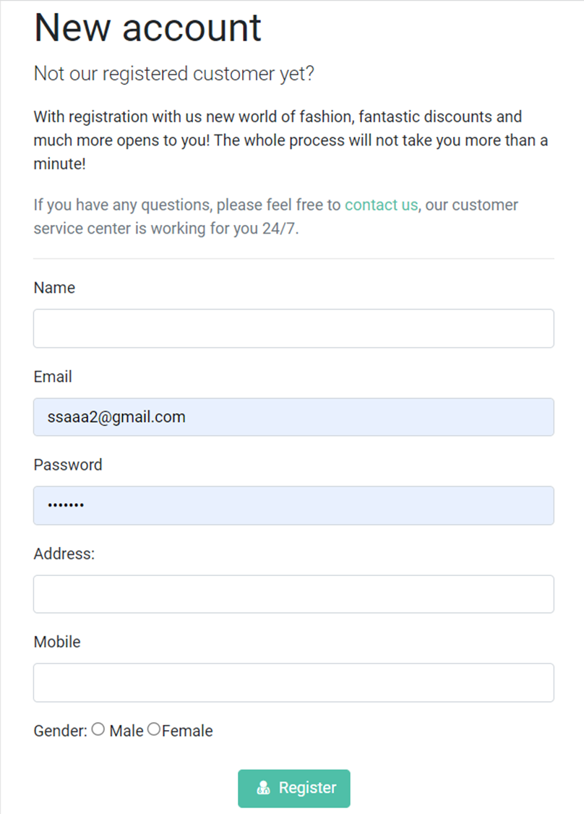

**Function Details:**

- Data Validation: When users fill out all the fields, our system will check their information and ensure that it is correct then send an email to the user's email which is filled above

- Data Processing: Users will enter the code that they receive through the email in the ”Signup Verification” screen. If sign up/register is successful, users will be sent to the login page to sign in/login

- Business Logic: The register function checks for any business rules or constraints and takes actions based on the application's registration requirements.

- Normal Case Functionality:

+ The user enters registration information in the respective fields.

+ Function to authenticate login information.

- If valid, the system sends an email to the user filled in above. The user will enter the code they received via email in the "Verify registration" screen

+ Abnormal case function:

+ User entered invalid information

- The system displays an error message and asks the user to register the correct information.

- If the user registers/registers successfully, he will be taken to the login page to login/login. If the information is incorrect, please re-fill the incorrect field.

**b. User Login**

**Function Trigger:**

- Triggers: User accessing the application or website.

- Navigation Path: User accessing the login page or clicking on the "Login" button on the interface.

**Function Description:**

- Explanation: The login function allows users to authenticate their identity to access the system or application. It plays a vital role in security and access management.

- Actors/Roles:

+ User: The individual who has an account and wants to access the system.

- Purpose: To authenticate the user's identity and grant them access to the application or system.

- Interface: The login interface typically includes data fields for the user to enter login information such as username and password. There are orther buttons like "Register" and "Forgot Password".

**Screen Layout:**

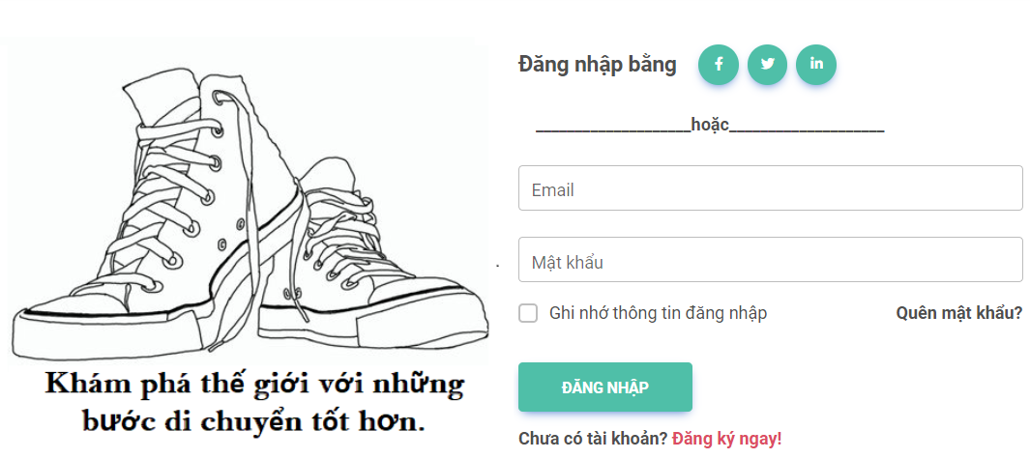

**Function Details:**

- Data Validation: The login function verifies the validity of the user-entered information, including checking if the username and password exist in the system.

- Data Processing: Upon successful authentication of the login information, the system will create a session for the user and provide corresponding access rights.

- Business Logic: The login function applies security rules and grants access based on user roles.

- Normal Case Functionality:

+ User enters login information in the respective fields.

+ Function verifies the login information.

+ If valid, the system grants access and redirects the user to the main interface or the previously accessed screen.

- Abnormal Case Functionality:

+ User enters incorrect username or password.

+ The system displays an error message and prompts the user to re-enter the correct information.

+ If the user forgets the password, a "Forgot Password" functionality can be provided to recover the password through email or other methods.

**c. User Change Password**

**Function Trigger:**

- Trigger: User accessing the application or website and being logged in.

- Navigation Path: User accessing the account settings or account management page and selecting the "Change Password" option.

**Function Description:**

- Explanation: The change password function allows users to update their current password to a new one for security purposes. It enables users to maintain control over their account and protect their personal information.

- Actors/Roles:

+ User: The individual who is logged in and wants to change their password.

- Purpose: To provide users with the ability to update their password and enhance account security.

- Interface: The change password interface typically includes data fields for the user to enter the current password, new password, and confirmation of the new password. There may be a "Save" or "Update" button to initiate the password change.

**Screen Layout:**

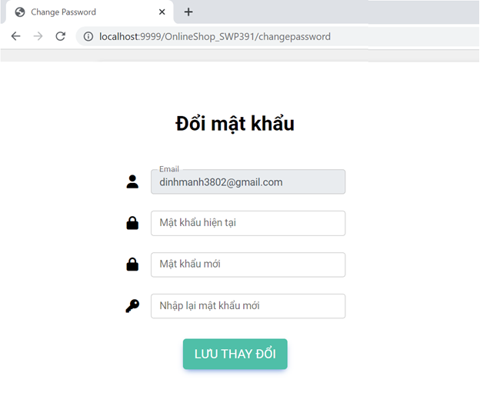

**Function Details:**

- Data Validation: The change password function validates the entered information, including verifying the current password matches the user's account and ensuring the new password meets the required criteria (e.g., minimum length, complexity).

- Data Processing: Once the entered information is validated, the system updates the user's password in the database and invalidates any existing sessions for security reasons.

- Business Logic: The change password function may incorporate additional security measures such as enforcing password history (preventing reuse of recently used passwords) and requiring periodic password changes.

- Normal Case Functionality:

+ User enters the current password, new password, and confirms the new password in the respective fields.

+ Function validates the entered information.

+ If valid, the system updates the password and notifies the user of the successful password change.

- Abnormal Case Functionality:

+ User enters an incorrect current password.

+ The system displays an error message and prompts the user to re-enter the correct current password.

+ If the entered new password does not meet the required criteria, the system notifies the user and specifies the password requirements.

+ If the confirmed new password does not match the entered new password, the system prompts the user to re-enter the matching passwords.

**d. User Reset Password**

**- Function Trigger:**

- Trigger: User initiating the password reset process by selecting the "Forgot Password" option.

- Navigation Path: User accesses the login page, clicks on the “Forgot Password” link or button, and enters their email address.

**Function Description:**

- Explanation: The reset password function allows users to regain access to their account by resetting their forgotten password.

- Actors/Roles:

- User: The individual who needs to reset their password.

- Purpose: To provide a secure and user-friendly process for users to regain access to their account.

- Interface: The interface includes a form where users can enter their email address to initiate the password reset process. Additionally, instructions may be provided on the steps to follow.

**Screen Layout:**

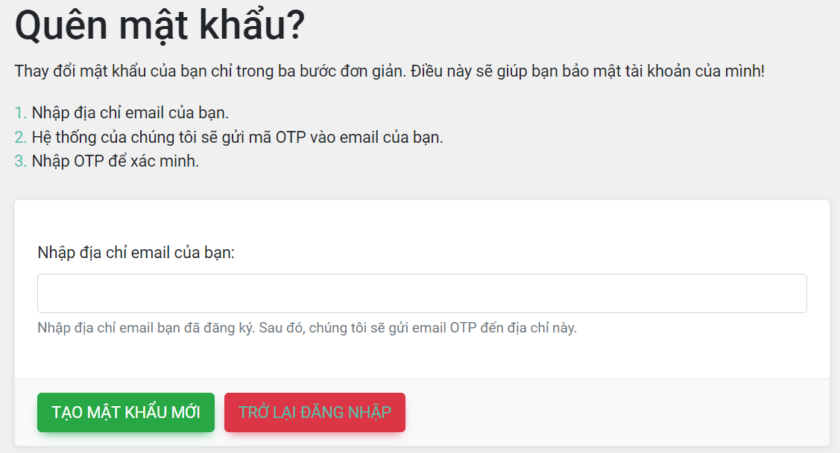

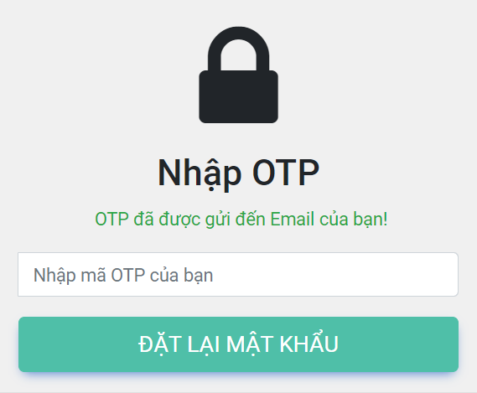

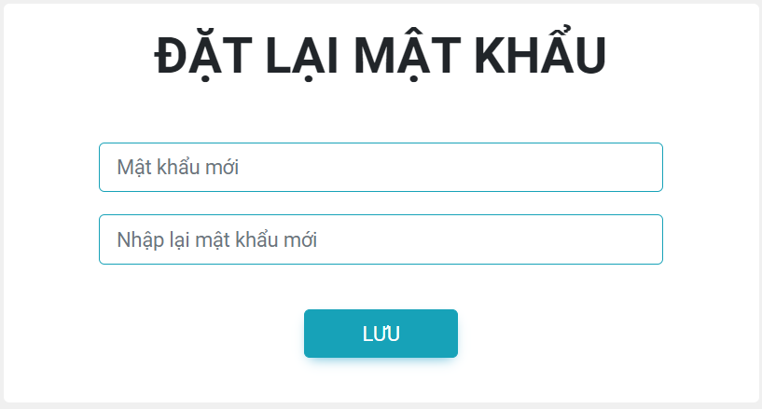

**Function Details:**

- Data: The function processes the entered email address to identify the associated user account.

- Validation: The function validates the entered email address to ensure it is associated with a registered account.

- Business Logic: The function follows the business rules for password reset, including identity verification by OTP and security measures to protect against unauthorized access.

- Normal Case Functionality:

+ Users enter their email address in the provided field and submit the form.

+ The system generates a One-Time Password (OTP) and sends it to the user's registered email address.

+ Users receive the password reset email containing the OTP and are prompted to enter it on the password reset page.

+ Users enter the received OTP in the provided field and submit the form.

+ The system verifies the entered OTP and allows the user to proceed to reset their password.

+ Users enter a new password and confirm it.

+ The system updates the password and notifies the user of the successful password reset.

- Abnormal Case Functionality:

+ If the entered email address is not associated with a registered account, an error message is displayed, prompting the user to enter a valid email address.

+ If the entered OTP is incorrect or expired, an error message is displayed, informing the user to enter the correct OTP or request a new one.

## 2.2 Homepage

**Function Trigger:**

- Trigger: User accessing the application or website home page.

**Function Description:**

- The home page function displays various elements such as sliders, hot posts, and featured products to provide users with an overview of the content available on the platform.

- Actors/Roles:

+ User: The individual accessing the home page.

- Purpose: To present engaging content to users and allow them to navigate to specific sliders, posts, or products based on their interests.

- Interface: The home page interface typically includes sections for sliders, hot posts, and featured products. Each section may contain images, titles, and brief information about the respective content.

**Screen Layout:**

* The website has a layout consisting of header, content and footer. There is no sider to display the latest post, but it will be in the content section. Because that helps to make the website layout more beautiful without causing an overall imbalance of the screen. The sider that displays the latest posts will be placed separately on the post list page.
* Slider only needs images without title because the website only wants to convey ads through images and it also brings more aesthetics to the website.

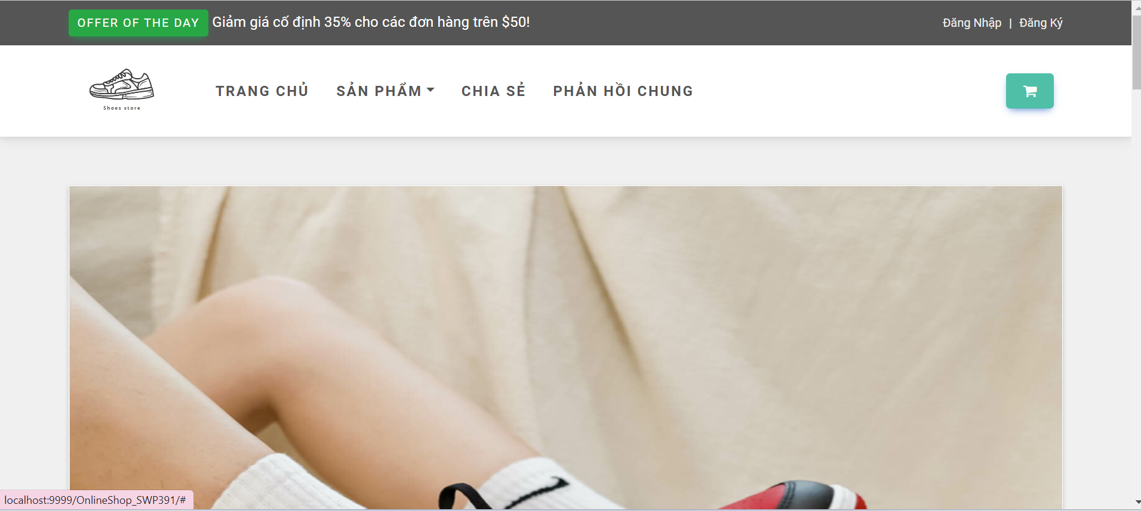

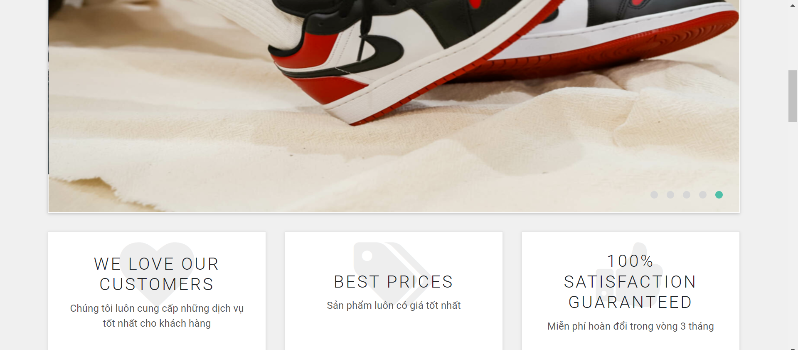

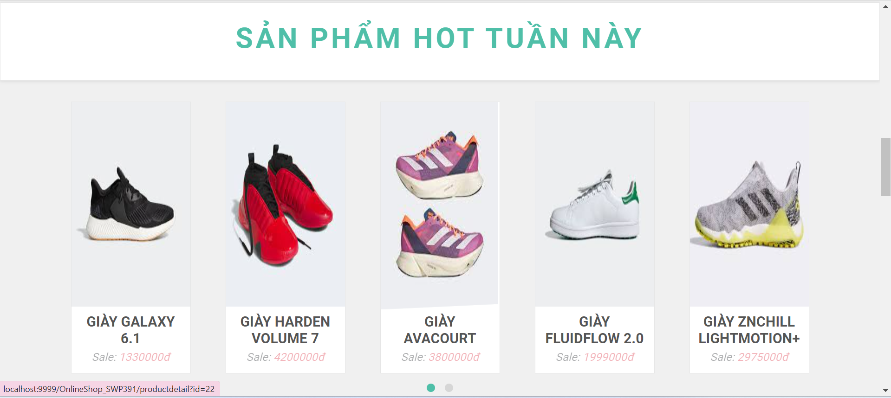

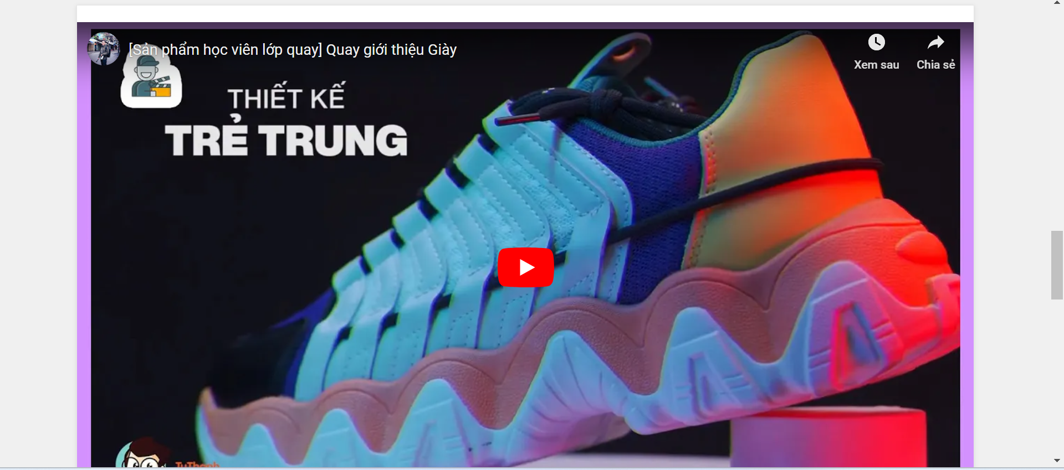

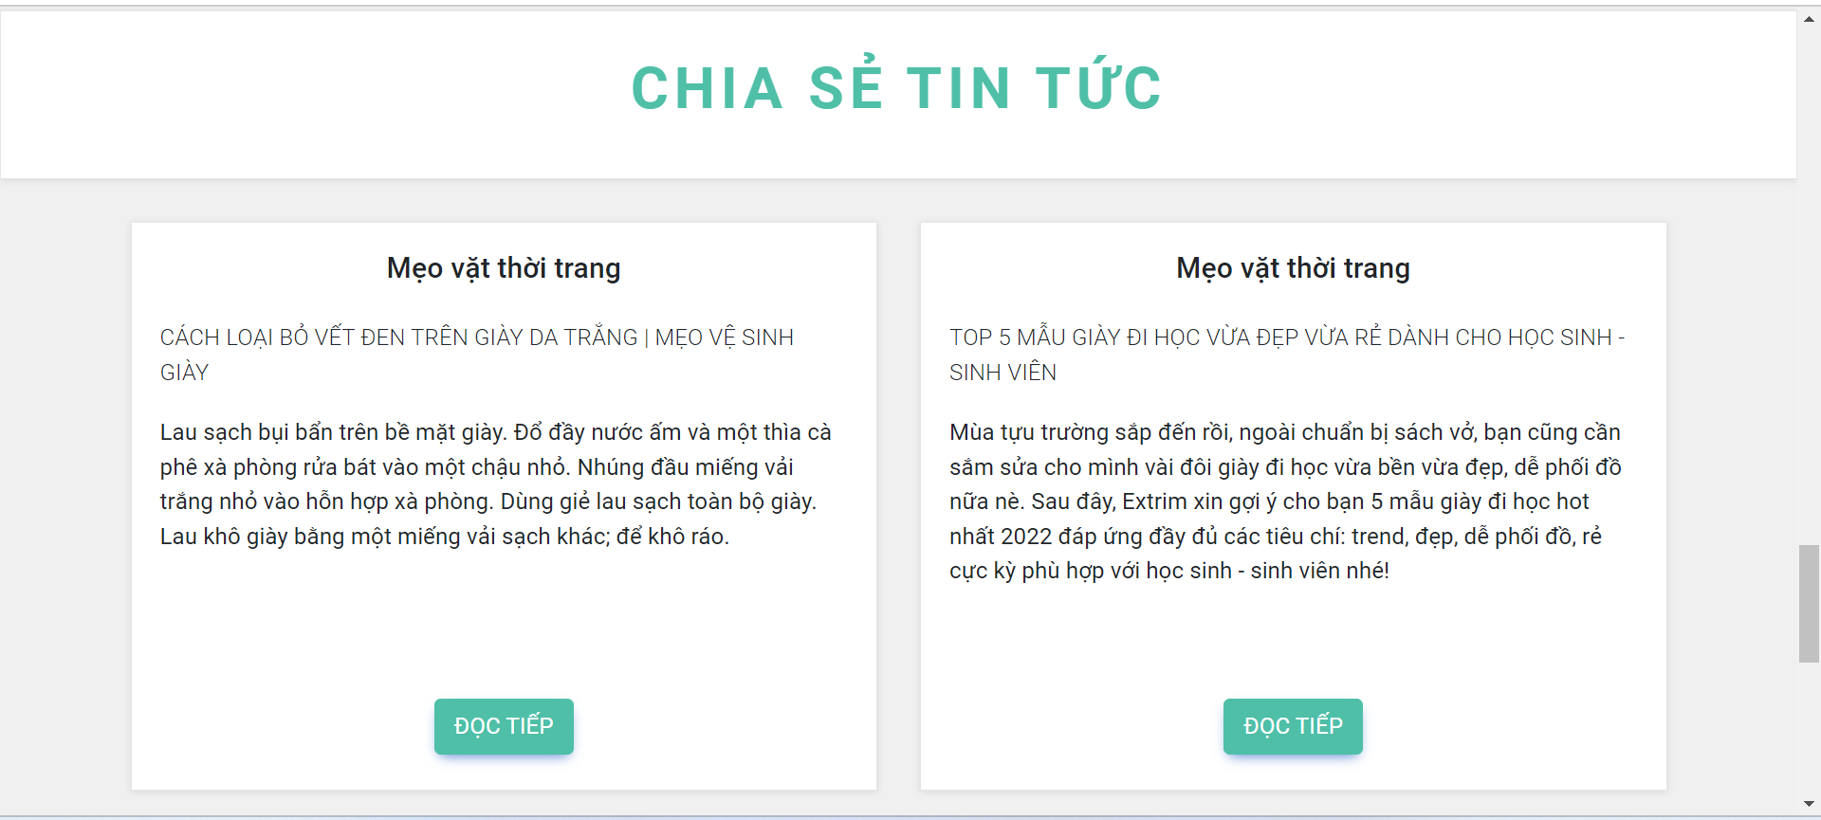

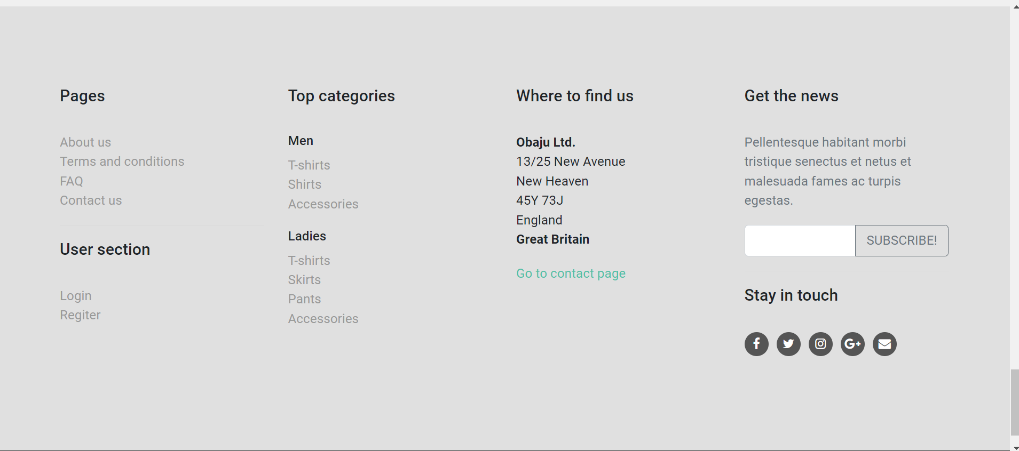

**Function Details:**

**\* Sliders:**

- Data: The sliders section includes multiple sliders with their respective images and titles.

- Validation: The sliders' data should be retrieved from a database or other data source and validated to ensure proper content display.

- Business Logic: The sliders are designed to attract user attention and encourage them to explore further by clicking on the slider.

- Functionality:

+ Normal Case: When the user clicks on a slider, they are redirected to the specified backlink related to the slider's content.

+ Abnormal Case: In case of any errors or issues with the sliders' data retrieval or display, an error message or alternative content can be shown.

**\* Hot Posts:**

- Data: The hot posts section includes multiple posts with their thumbnails, titles, and brief information.

- Validation: The hot posts' data should be retrieved from a database or other data source and validated to ensure proper content display.

- Business Logic: The hot posts aim to showcase popular or trending posts to attract user interest.

- Functionality:

+ Normal Case: When the user clicks on a hot post, they are redirected to the details page of the respective post.

+ Abnormal Case: In case of any errors or issues with the hot posts' data retrieval or display, an error message or alternative content can be shown.

**\* Featured Products:**

- Data: The featured products section includes multiple products with their thumbnails, titles, and brief information.

- Validation: The featured products' data should be retrieved from a database or other data source and validated to ensure proper content display.

- Business Logic: The featured products highlight specific products of interest or promotions.

- Functionality:

+ Normal Case: When the user clicks on a featured product, they are redirected to the details page of the respective product.

+ Abnormal Case: In case of any errors or issues with the featured products' data retrieval or display, an error message or alternative content can be shown.

## 2.3 Product List

**Function Trigger:**

- Triggers: :Use Seen Product List.

**Function Description:**

- Explanation: Show all product by category

- Actors/Roles:

+ User: Individuals who do not have an account and want to seen product by category

- Purpose: To help people poduct and product information to be able to buy in the website

- Interface: This page shows a list of products when users click on a “Product” in the header. Users can filter their products they want to buy based on ”Price”,”Brand”, and can sort the list through the “Sorting” button. The list below shows title, attributes and price of products paginated(before/after sort).

**Screen Layout:**

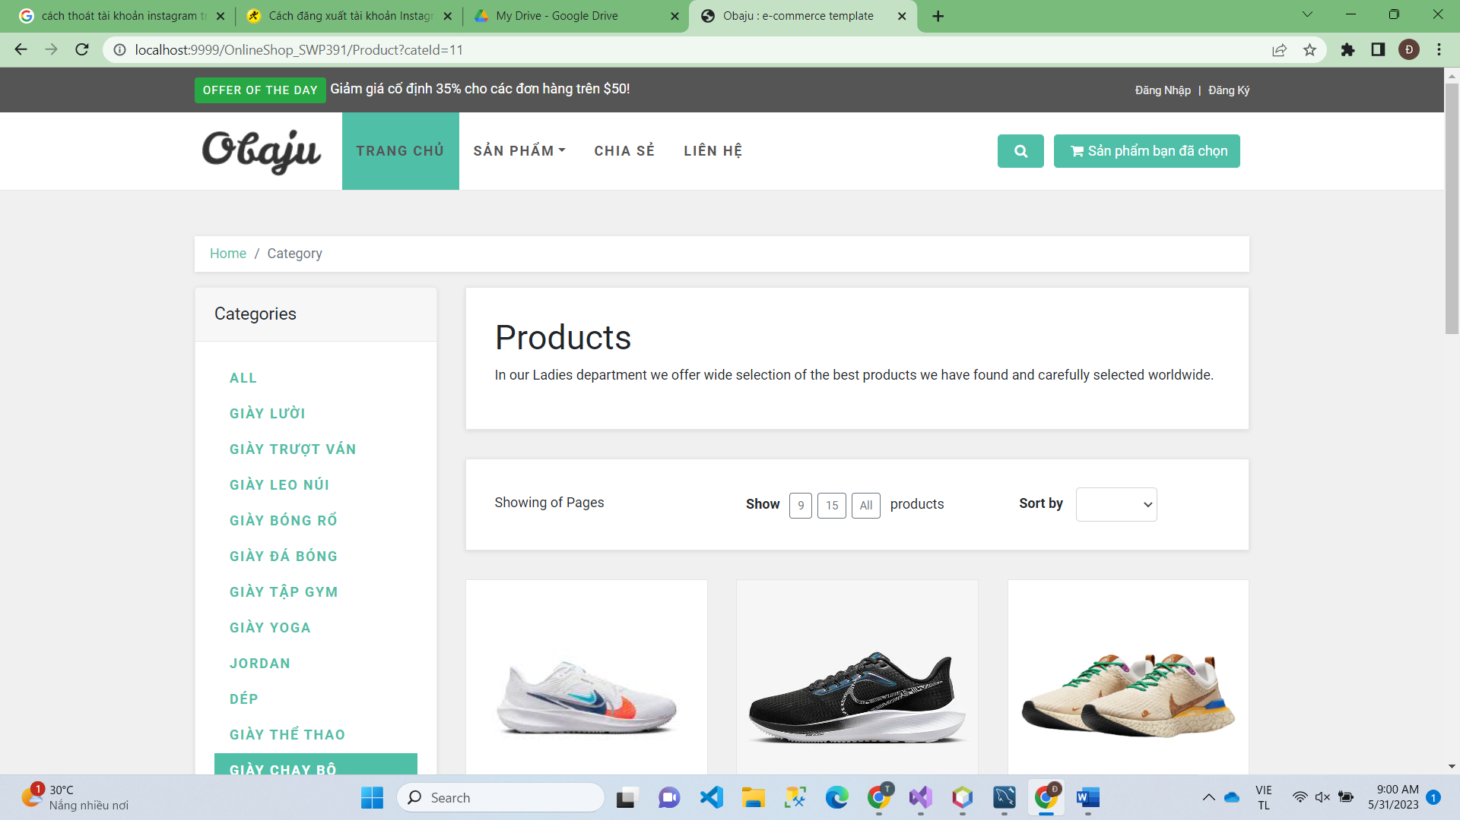

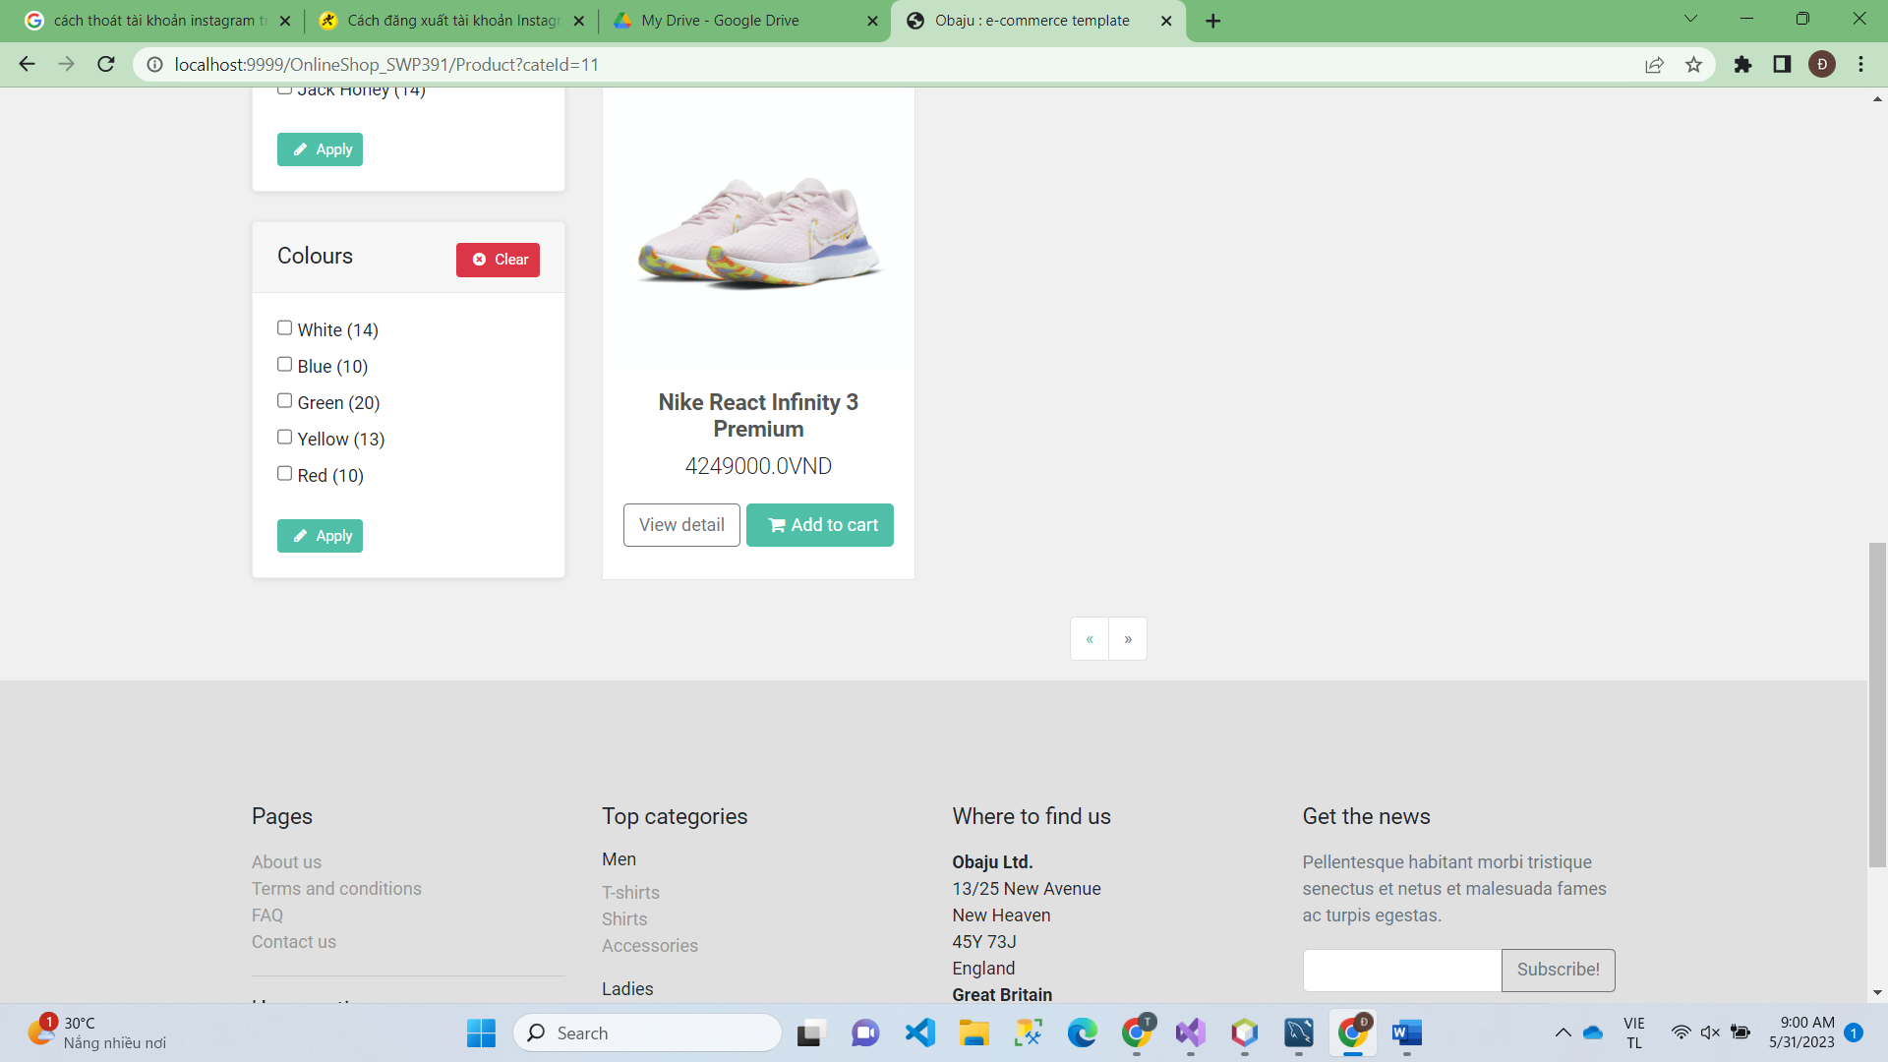

**Function Details:**

- Data Validation: When users find all the productlist, our system will show their information and multiple choice to user can search sort and buy

- Business Logic: The productlist page shows a list of products when users click on a “Product” in the header. Users can filter their products they want to buy based on ”Price”,”Brand”, and can sort the list through the “Sorting” button. The list below shows title, attributes and price of products paginated(before/after sort).

- Normal Case Functionality:

+ Show list product for user.

+ Sorting product by name by price.

+ Select all product by name category

+ If valid, the system sends an email to the user filled in above. The user will seen the product they want to buy and information of them.

+ User entered invalid information.

+ The system displays an the product dont have.

## 2.4 Product Detail

**Function Trigger:**

- Trigger: When users click on the shoe category, they will give information and feedback

- Navigation Path: Users accessing product details will give feedback on price and size and also feedback for users to fill in

**Function Description:**

- Explanation:

+ When entering the product details, the user can see the price, size and feedback. Then there will be a shopping cart and an order to help the user buy.

- Actors/Roles:

+ User: Individuals who are logged in and want to see product information to buy

- Purpose:

+ Help users have detailed product information so that users can choose quality products

- Interface:

+ The product detail interface will have the price of the product and user feedback. It has boxes like shopping cart and box to place an order.

**Screen Layout:**

* No sider because want to maximize the interface for product display.

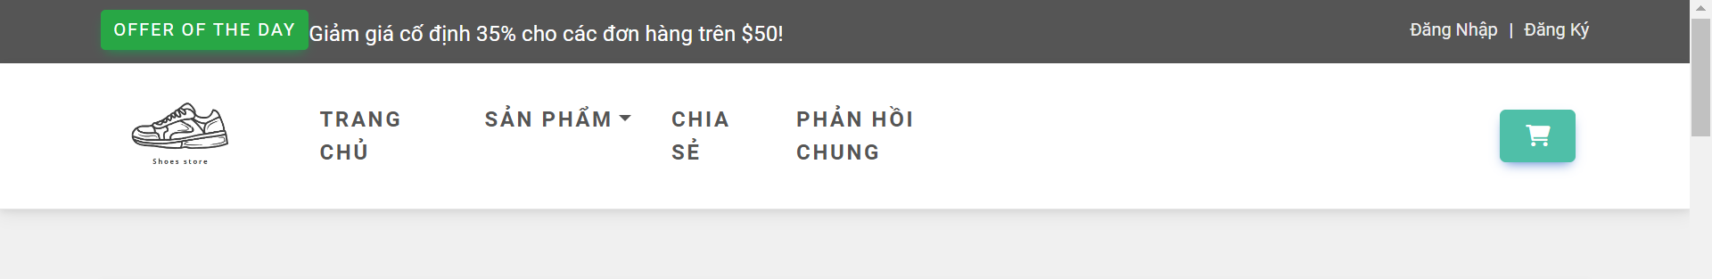

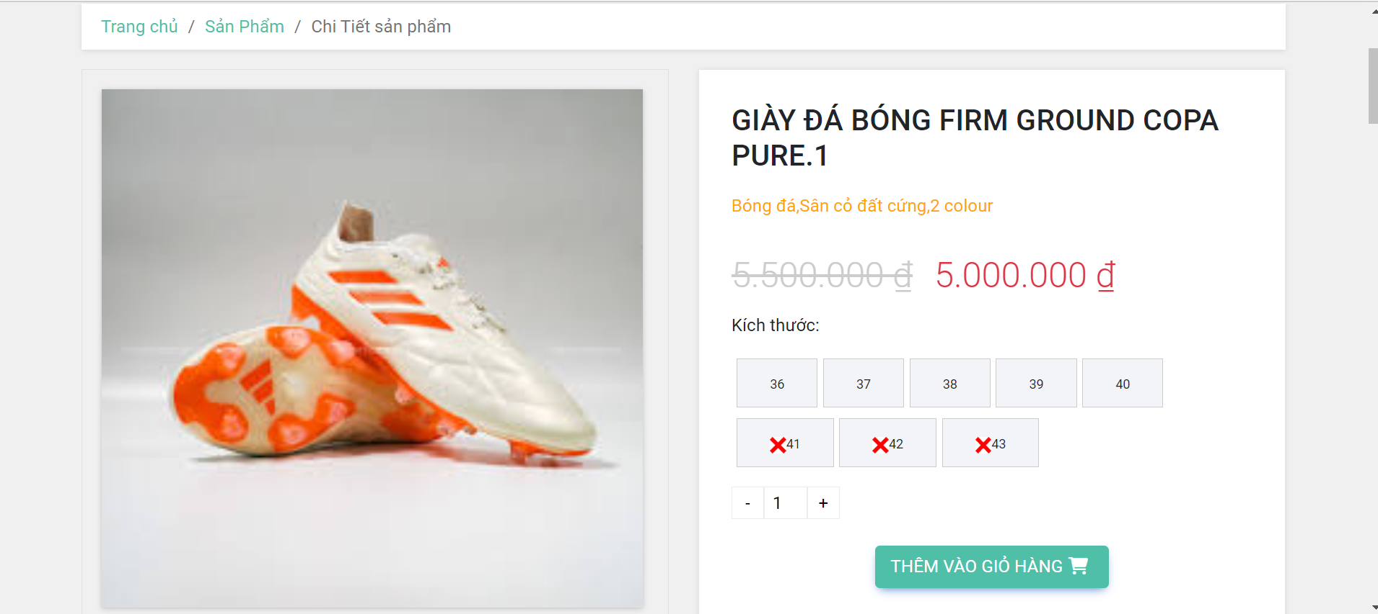

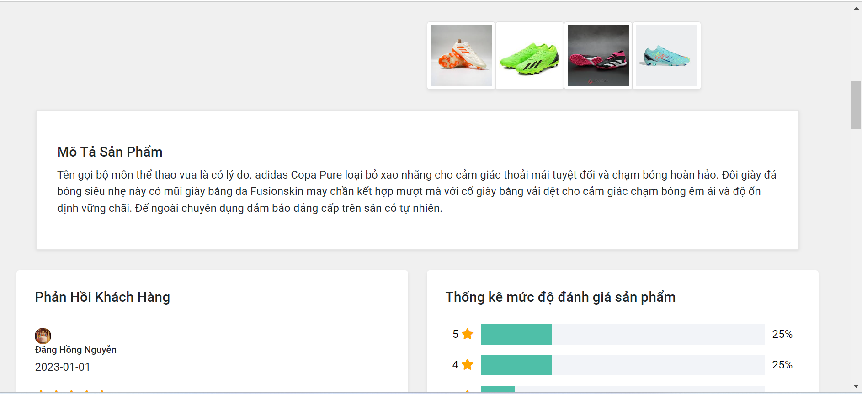

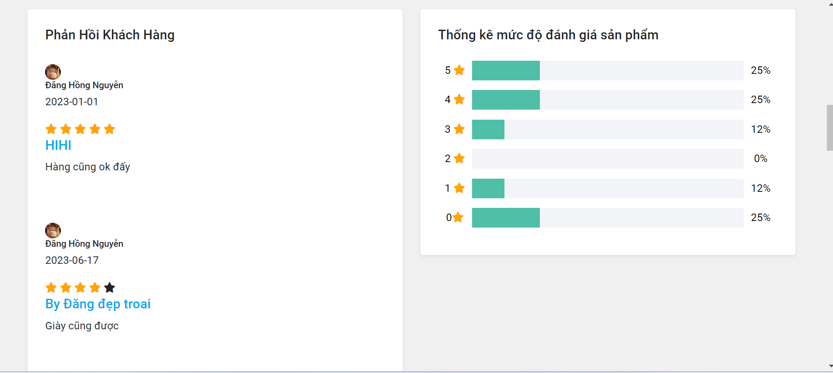

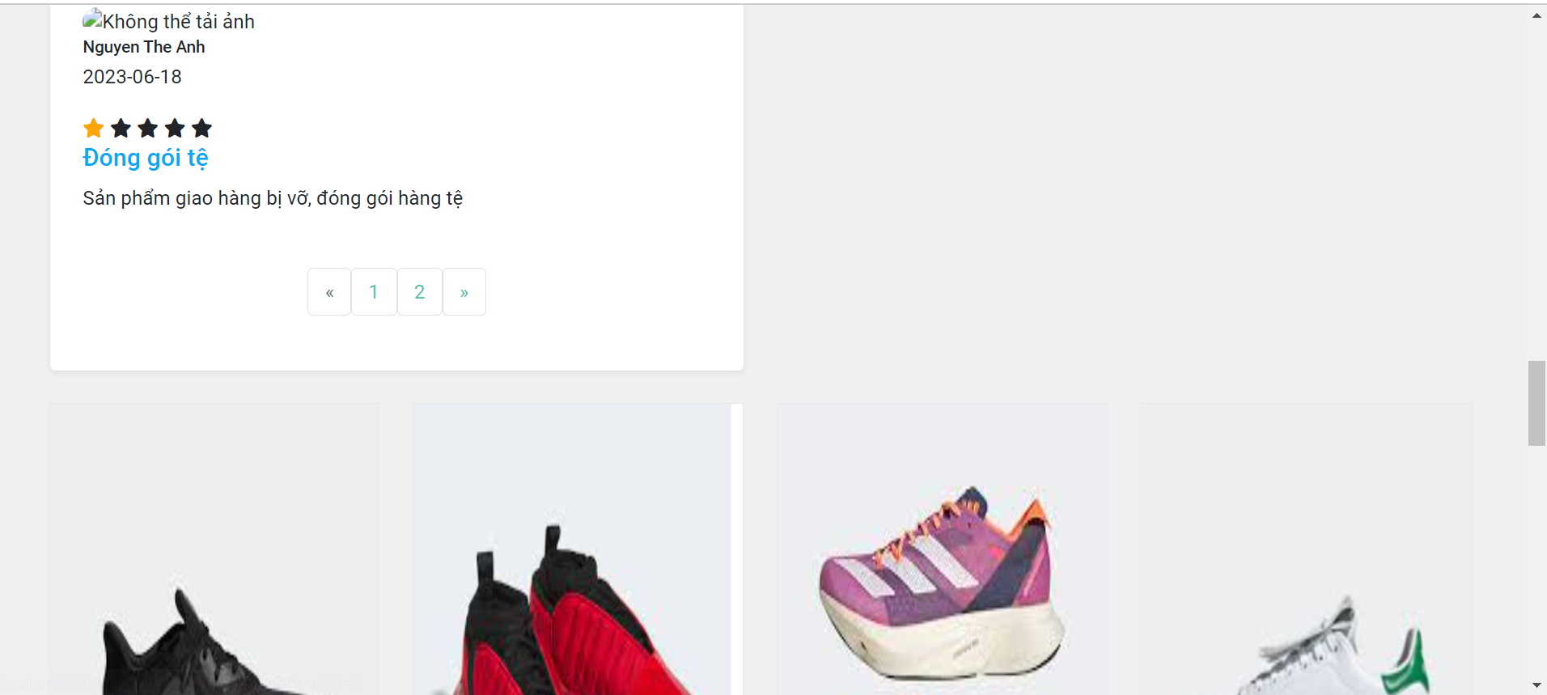

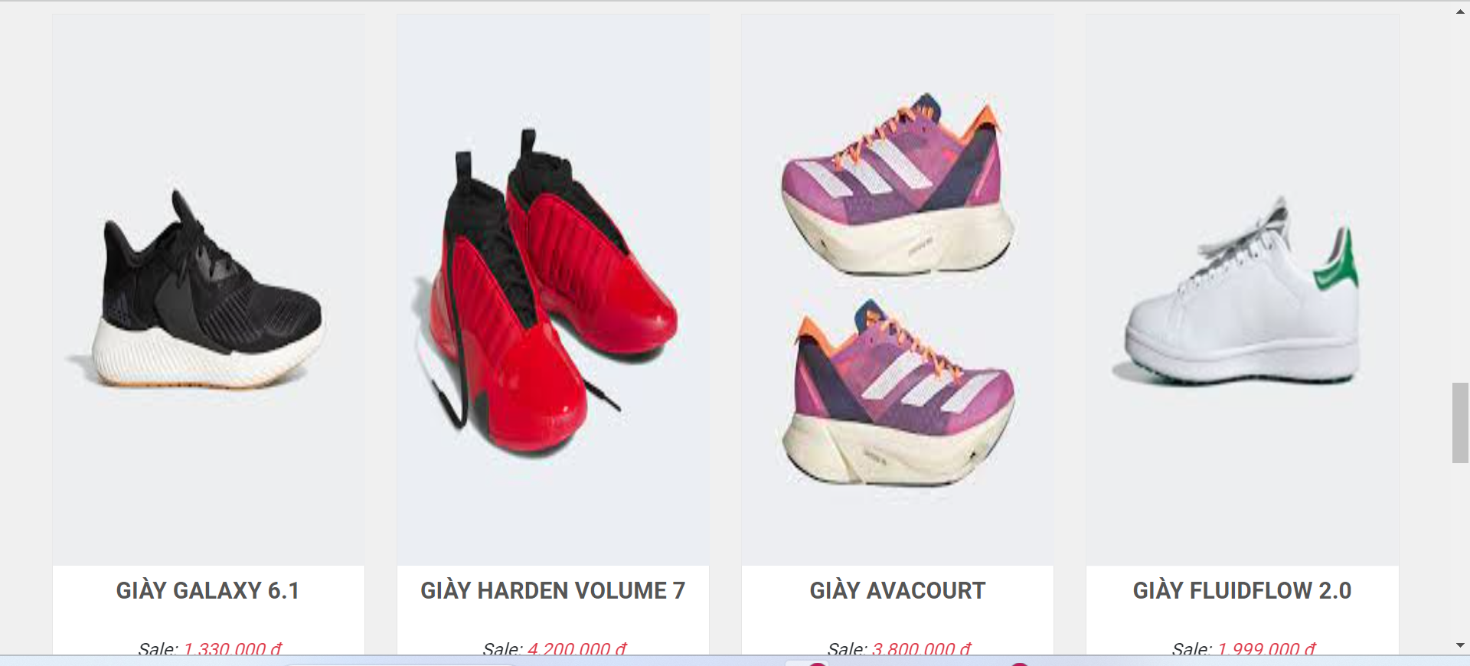

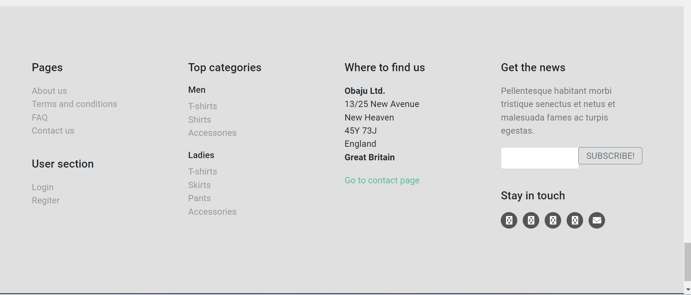

**Function Details:**

- Data Validation: In product detail there are always right typeface and product must have price and discount and full size for product

- Data Processing: Once the entered information is validated, the system updates product detail for user

- Business Logic: This page shows the descriptions of products when users click on a product of a products list. It includes the product’s name, some images of the product, sizing chart for men or women when choosing size,quantity of product that users want to buy, add to cart button when users decide to buy these products,detailed description of these products and recommend similar products. When users want to back to the products list, they will click on “Product” in header, the page will redirect to Products list

- Normal Case Functionality:

+ There is a form to fill out information for users

+ Sider contacts, information and items give feedback

+ There are pictures and prices with 4 sizes for users to choose

## 2.5 Blog List

**Function Trigger:**

- Trigger: User visits the website and clicks on the "Share" button.

- Navigation Path: After successful login, on the homepage, selecting the "Share" section on the title bar will lead to the blog listing page.

**Function Description:**

- Explanation: This function allows users to access the blog list, view posts, and search for blogs by name and post classification for easy navigation.

- Actors/Roles: Guests, users

- Purpose: To display a list of blogs, enabling users to search for topics of interest.

- Interface: The interface presents the blog posts in a paginated manner, sorted by the updated date. The sidebar includes a search box for blog posts, post categories, latest posts, and static contacts/links. Each blog post is presented with a thumbnail, title, and brief summary. Clicking on a blog post redirects the user to the detailed blog post page.

**Screen Layout:**

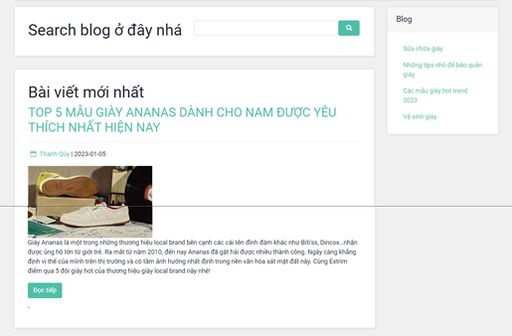

**Function Details:** The page displays the title, author, date, and summary content of each blog post. Clicking on the title redirects the user to the detailed blog post page.

- Data Validation:

+ Validate the URLs of blog posts to ensure users can access the related websites.

+ Validate the length and validity of the blog post's title and body to prevent excessively long or incomplete information.

+ Validate user input, such as search fields or registration information.

+ Validate the image format, if applicable, for the blog list's thumbnail images.

- Data Processing:

+ Retrieve information from the database and process it to populate the website with the blog post data.

- Business Logic:

+ Allow readers to easily search for articles on topics they are interested in.

+ Support increased traffic for the blogs listed in the blog list.

+ Help promote blogs and improve marketing efficiency.

+ Provide readers with a resource to learn about specific topics.

+ Foster a community by connecting bloggers and readers.

- Normal Case Functionality:

+ Display a list of the latest added blog posts.

+ Allow users to view the title of each blog post and click to read the detailed content on the blog's website.

+ Support a search function for users to find posts related to their topics of interest.

- Abnormal Case Functionality:

+ Users mistakenly click on links that lead to other pages.

+ Users enter incorrect blog keywords, resulting in the inability to find the desired blog posts.

## 2.6 Blog Detail

**Function Trigger:**

- Trigger: User visits the website and clicks on the "Share" section, then selects a blog post to view detailed information.

- Navigation Path: After successful login, on the homepage, selecting the "Share" section on the title bar will lead to the blog list page. Users need to click on a specific blog post to view its details.

**Function Description:**

- Explanation: This function allows users to access and view detailed information about individual blog posts.

- Actors/Roles: Guests, users

- Purpose: To provide users with in-depth information about the selected blog post and enable them to gain knowledge about the topic.

- Interface: The interface displays detailed post information, including a thumbnail, category, title, brief summary, description, and options to turn on/off the featuring flag and modify the status. Users can input, view, or edit the posts.

**Screen Layout:**

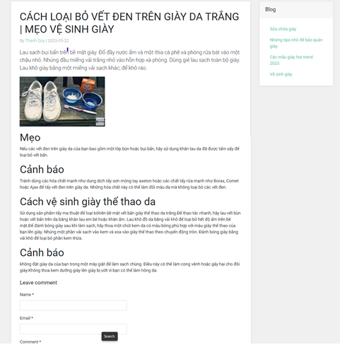

**Function Details:**

- The page presents the title, author, date, and summary content of the blog post. Clicking on the post title redirects the user to the detailed blog post.

- Data Validation:

+ Validate the URL to ensure users can access the relevant website.

+ Validate the length and validity of the post's title and body to prevent excessive length or incomplete information.

+ Validate the images used in the post, including their format, size, and resolution.

+ Validate the tags and HTML code formatting used in the post to ensure proper display across web browsers.

- Processing: Retrieve information from the database and process it to display the detailed blog post on the website.

- Business Logic:

+ Back feature: The back button is programmed to allow the reader to navigate back to other blog posts. The business logic ensures that clicking the back button triggers the return to the previous blog post page.

+ Search feature: The search functionality is programmed to help users find related posts. The business logic ensures that searching is triggered when the user enters a search keyword and initiates the search.

+ Image and video thumbnail feature: The business logic ensures that thumbnail images and videos are displayed correctly in the appropriate size and format. If the post includes images or videos, the business logic ensures the optimal display to engage readers.

- Normal Case Functionality:

+ Display the complete post content, including the title, body, and accompanying images/videos.

+ Allow users to navigate to other blog posts through menus or related links.

+ Enable users to search for related posts using the search function on the blog site.

+ Notify users of errors or issues related to the display of post content, such as path errors, image display problems, syntax errors, or connection issues.

- Abnormal Case Functionality:

+ Users mistakenly click on another blog post.

## 2.7 My Order

**Function Trigger:**

- Triggers: Use show list My order.

**Function Description:**

- Explanation: Show all product list order

- Actors/Roles:

+ User: Individuals who have an account and want to see list order of them.

- Purpose: Show the list of user's orders paginatedly + the sider with the product search box, product categories, the latest products, and static contacts/links

- Interface: Each order include below information: id, ordered date, product (first product name & number of other products if any), total cost, status; On clicking the link under the order id, user would be redirected to the Order Information page

**Screen Layout:**

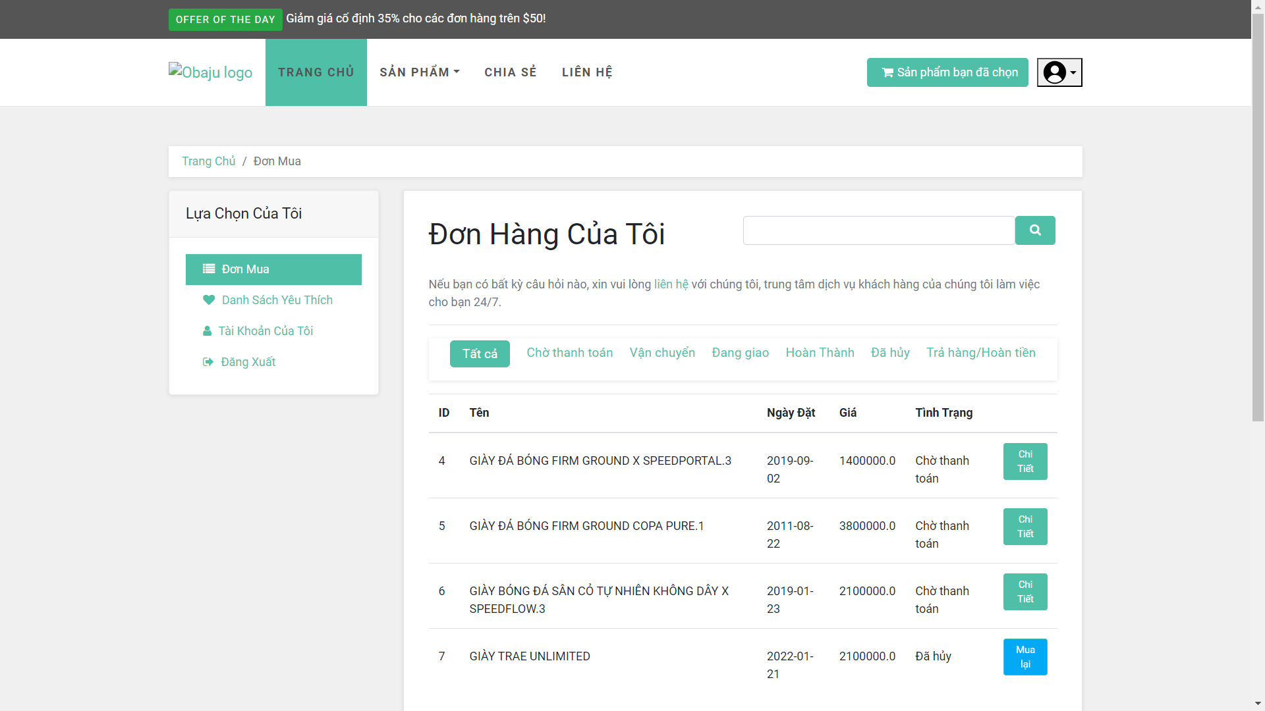

**Function Details:**

- Data Validation: When users find all the productlist, our system will show their information and multiple choice to user can search sort and buy

- Business Logic: The productlist page shows a list of products when users click on a “Product” in the header. Users can filter their products they want to buy based on ”Price”,”Brand”, and can sort the list through the “Sorting” button. The list below shows title, attributes and price of products paginated(before/after sort).

- Normal Case Functionality:

+ Show list order for user.

+ Sider with the product search box, product categories, the latest products, and static contacts

## 2.8 Feedback

**Function Trigger:**

- Triggers: User and guest can fill in the feedback

**Function Description**

- Explanation: Fill in the feedback

- Actors/Roles:

- User: can fill in the feedback

+ Guest: Enter email with password and feedback

- Purpose: Users and guests can communicate with the site and send general feedback

- Interface: The table will display a bar for users and guests to fill in the feedback content

**Screen layout for User:**

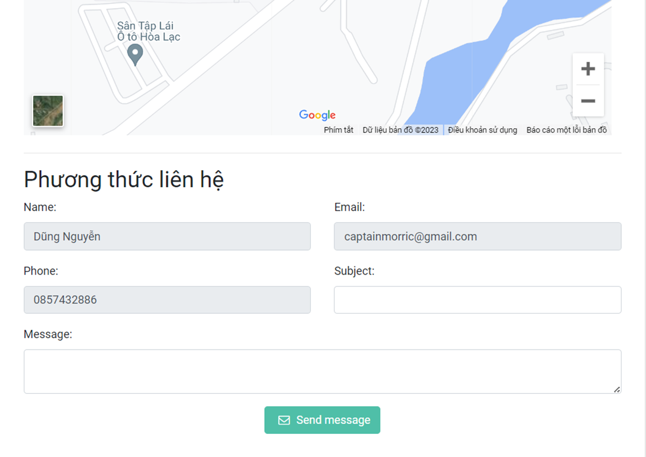

**Screen layout for Guest:**

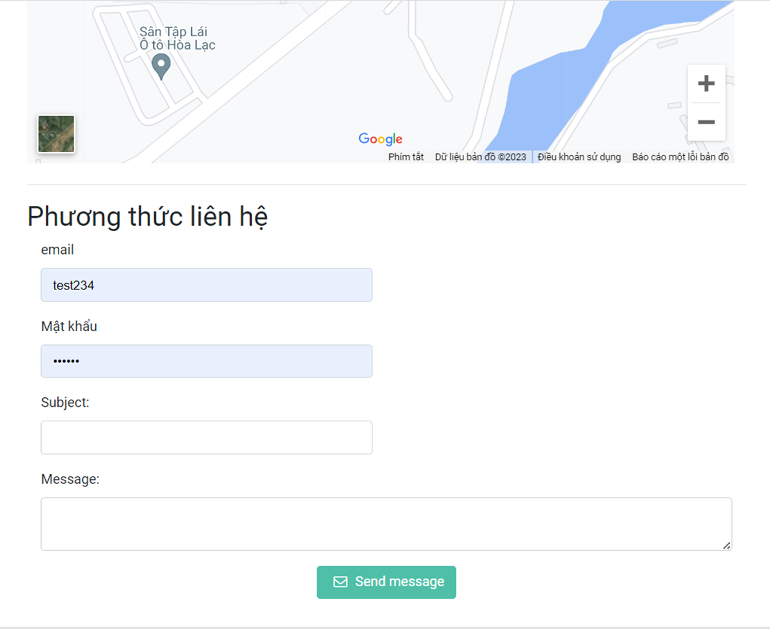

**Function Details:**

- Data validation:

+ When the user clicks on the contact item, our system will display the information for the user to fill in and the guest will enter the account and password to send feedback.

+ After insert feedback user will be receive an email

- Business Logic: **:** This screen is after the user visits the contact section then clicks the feedback button in the contact section of the website. User enters all fields to submit feedback. Guest will login and then give a new response

- Normal Case Functionality:  
 + There is a form to fill out information for users and guests

+ Sider contacts, information and items give feedback

## 2.9 Customer List

**Function Trigger:**

- Triggers: : Marketing login to manage customers

- Navigation path: new marketing accounts login to manage customer list

**Function Description:**

- Explanation:

+ User lists refer to customer information that allows marketers to gain access to specific features or resources.

- Actors/Roles:

+ Marketing: Accounts have a separate role id for marketing to log in to the customer list

- Purpose: Help marketing manage customers in the website

- Interface: Show the list of customers (include contacts' id, full name, gender, email, mobile, status)

**Screen Layout:**

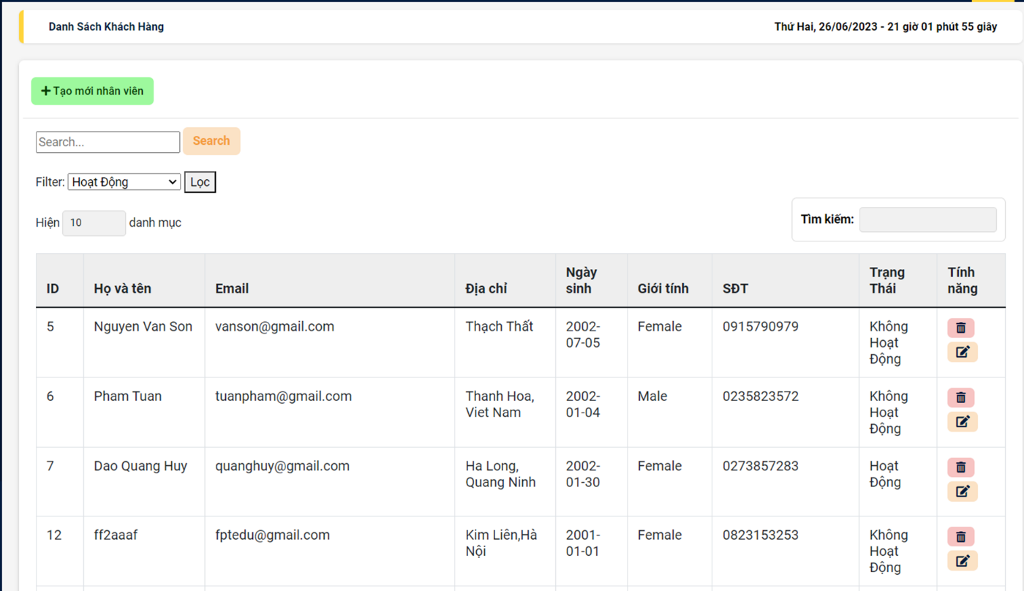

**Function Details:**

- In this page, marketing can view each customer's information and can't edit anything, just edit the user's status, in addition, can create for customers and after creating, will send customers mail to their account. and password

- Data Processing: Here we enter the name, phone, email and adjust the status and can add users

- Business Logic: The manager customer list function checks for any business rules or constraints and takes actions based on the application's manager customer list requirements.

- Normal Case Functionality:

+ Marketing can view each customer's information and can't edit anything, just edit the user's status, in addition, can create for customers and after creating, will send customers mail to their account. and password

## 2.10 Customer Details

**Function Trigger:**

- Triggers: Marketing login to manage status manager and add customer

- Navigation path: new marketing accounts login to manage customer list- **Function Description:**

- Explanation:

+ User lists refer to customer information that allows marketers to gain access to specific features or resources.

- Actors/Roles:

+ Marketing: Accounts have a separate role id for marketing to log in to the customer list.

- Purpose: Help marketing manage customers in the website.

- Interface: Show the list of customers (include contacts' id, full name, gender, email, mobile, status,avatar).

**Screen Layout:**

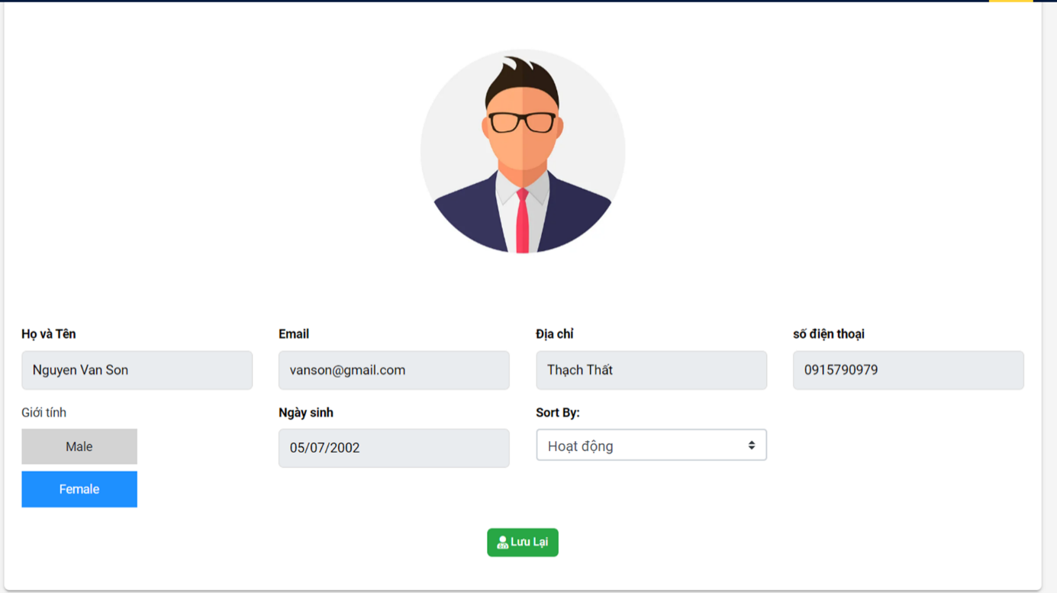

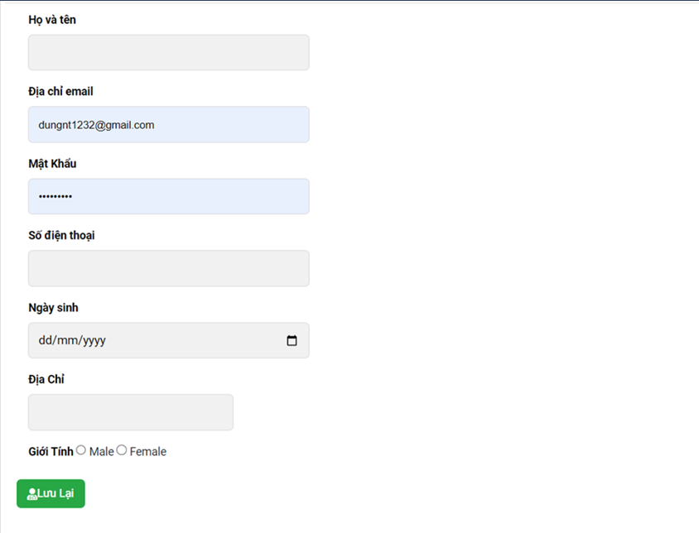

**Function Details:**

- In this page marketing can search name, email, phone number. And can filter account active and inactive status. And this can be Sortable by full name, email, mobile, status…

- Data Processing: Here we enter the name, phone, email to search for customers and can choose the status we want to show and want to sort by the desired column.

- Business Logic: The manager customer details function checks for any business rules or constraints and takes actions based on the application's manager customer details requirements.

- Normal Case Functionality:

+ Marketing can view each customer's information and can't edit anything, just edit the user's status, in addition, can create for customers and after creating, will send customers mail to their account. and password.

## 2.11 Users List

**Function Trigger:**

- Triggers: Admin accessing the users list page.

- Navigation Path: Admin navigating to the users list page from the main interface or using a specific menu option.

**Function Description:**

- Explanation: The users list function displays a paginated list of registered users with their relevant details. It provides various features to filter, search, sort, view, and edit user information.

- Actors/Roles:

+ Admin: The authorized user with administrative privileges.

- Purpose: To manage and monitor the registered users within the system.

- Interface: The users list interface presents the paginated list of users with columns displaying their id, full name, gender, email, mobile, role, and status. Additionally, there are options to filter, search, sort, view, edit, and add new users.

Screen Layout:

[Layout description of the users list interface]

**Function Details:**

- Data Presentation: The function presents a paginated list of registered users, including their id, full name, gender, email, mobile, role, and status.

- Data Validation: The function validates the input data to ensure its accuracy and integrity. It checks for any missing or incorrect information when filtering, searching, or sorting the user list.

- Data Processing: The function processes the user data to generate the paginated list and apply filters, search queries, and sorting preferences.

- Business Logic: The function implements the business rules related to user management, such as handling access rights, role-based permissions, and status-based functionalities.

- Normal Case Functionality:

+ Admin enters filter criteria, search keywords, or sorting preferences.

+ The function validates the input data.

+ The system processes the input and generates a paginated list of users based on the provided criteria.

+ The admin can view or edit user information by selecting the appropriate option from each user's entry in the list.

+ The admin can add a new user by clicking on the designated button/link.

- Abnormal Case Functionality:

+ Admin enters incorrect filter criteria, search keywords, or sorting preferences.

+ The function detects the invalid input and displays an error message.

## 2.12 User Detail

**Function Trigger:**

- Triggers: Admin or user accessing the user details page.

- Navigation Path: Admin or user navigating to the user details page from the users list or using a specific menu option.

**Function Description:**

- Explanation: The user details function displays comprehensive information about a specific user, including their avatar, full name, gender, email, mobile, role, address, and status. It allows users to add new users, as well as view and edit existing user information. The admin has additional capabilities to edit/update the user's role and status.

- Actors/Roles:

+ Admin: The authorized user with administrative privileges.

+ User: An individual registered within the system.

- Purpose: To provide detailed user information and enable necessary actions such as adding new users, viewing, and editing user information.

- Interface: The user details interface presents the user's detailed information, including their avatar, full name, gender, email, mobile, role, address, and status. It also provides options to add a new user, view, or edit the user's information.

**Screen Layout:**

[Layout description of the user details interface]

**Function Details:**

- Data Validation: The function validates the input data for adding a new user, ensuring the completeness and accuracy of the provided information.

- Data Processing: Upon successful addition of a new user, the system processes the entered information, generates a new login password, and sends it to the new user via email.

- Business Logic: The function enforces business rules related to user management. The admin is granted the authority to edit/update the role and status of the user, while other fields remain editable by the user themselves.

- Normal Case Functionality:

+ User selects the option to add a new user.

+ The function validates the completeness and accuracy of the entered information.

+ If the information is valid, the system processes the data and creates a new user account.

+ The system generates a new login password and sends it to the new user via email.

- Abnormal Case Functionality:

+ User enters incomplete or inaccurate information for adding a new user.

+ The function detects the invalid input and displays an error message.

+ The system prompts the user to correct the input information.

+ If the user forgets their password, they can utilize the "Forgot Password" functionality, which allows them to recover their password through email or other specified methods.

## 2.13 Slider List

**Function Trigger:**

- Trigger: User clicks on Slider list on the managed list

- Navigation Path: After the user has successfully logged into the account, the management interface will appear, the menu will display the management list and the user will click on the slider list.

**Function Description:**

- Explanation: The function allows users to access the slider list, the user can filter the sliders by status + search by title or backlink, for each slider, the user can choose to hide, show, edit, delete, or add it.

- Actors/Roles: Marketing.

- Purpose: Displays a list of sliders for users to manage.

- Interface: Show the paginated list of sliders (including sliders' id, title, image, backlink, and status), with search by title and sorted by sliders' id, title, image, backlink, status, with function buttons to hide, show, add, delete slider.

**Screen Layout:**

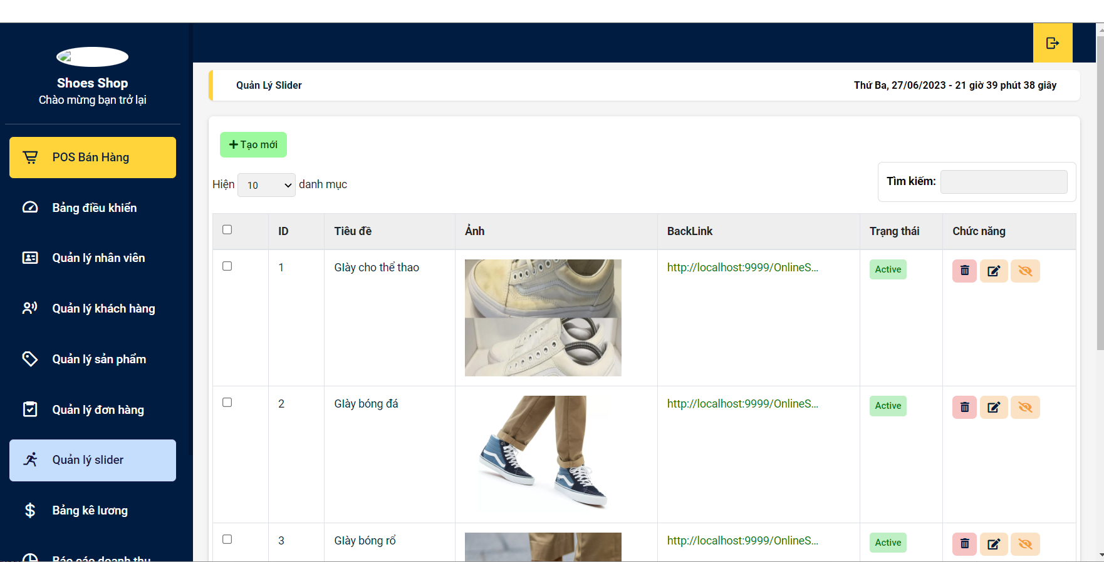

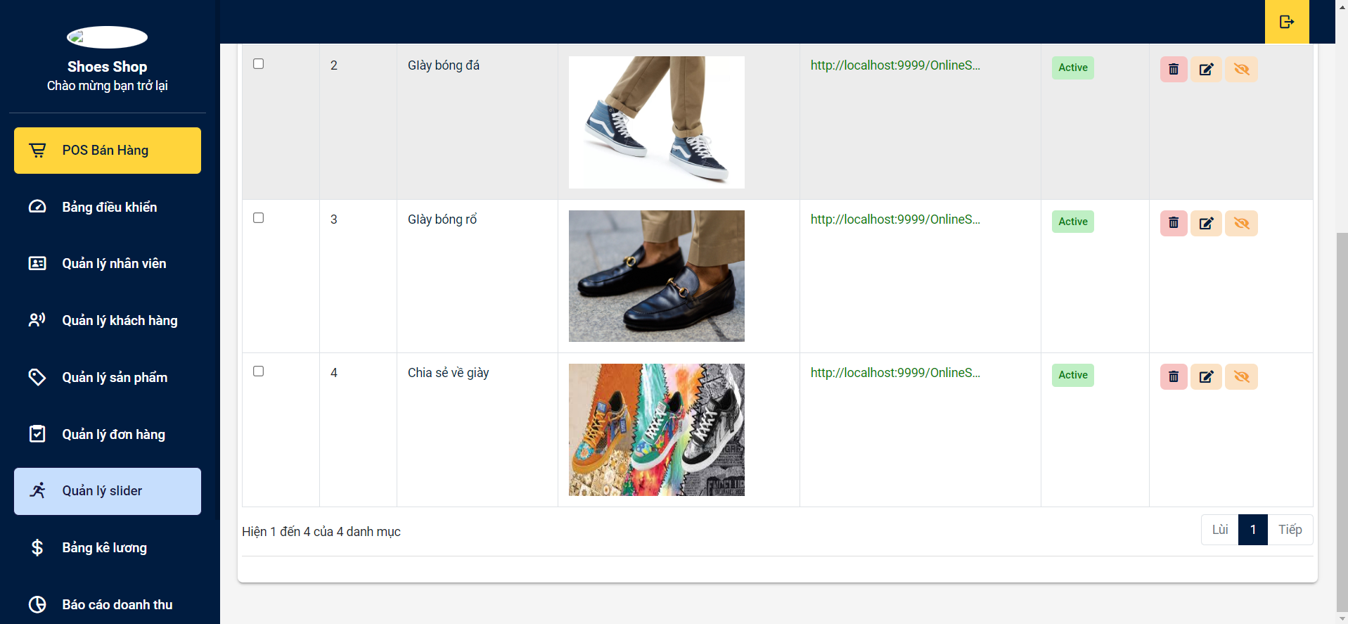

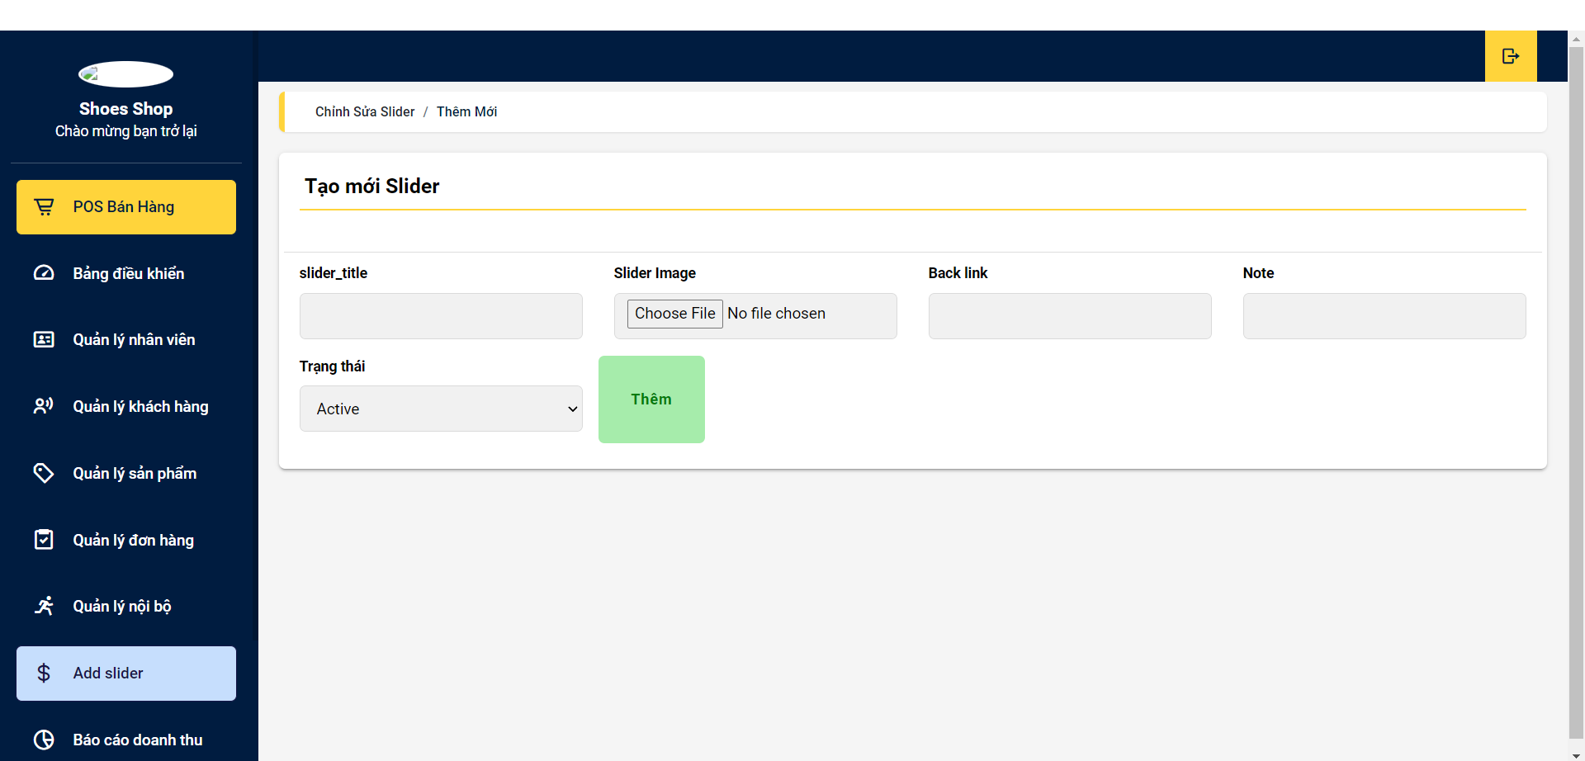

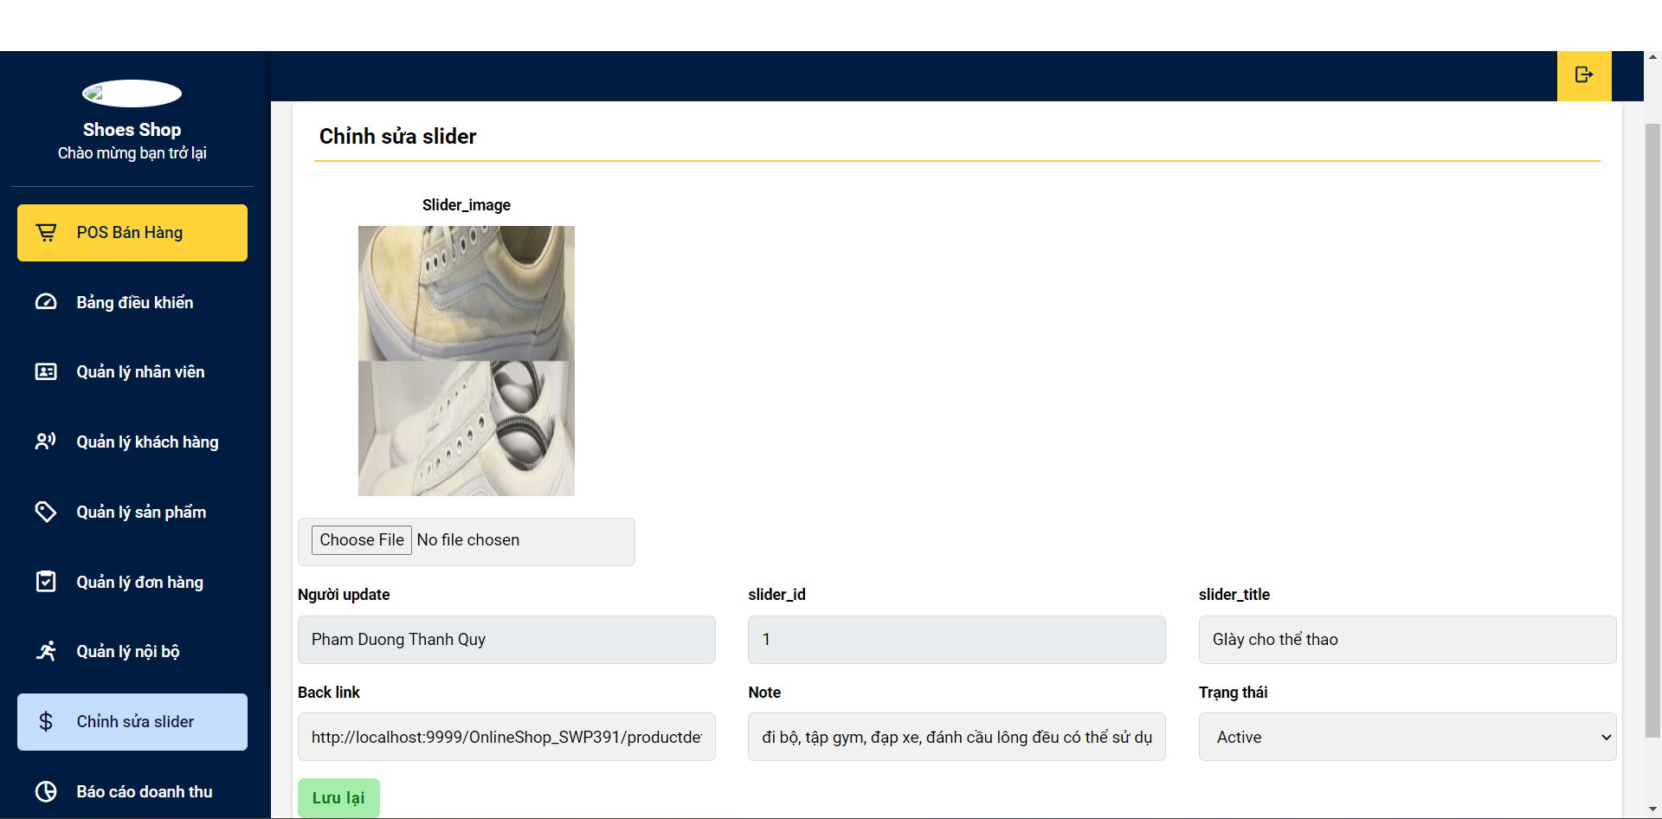

**Function Details:**

**-** The page displays the sliders' id, title, image, backlink, and status. If the user clicks on the title, it will redirect them to the slider details.

- Data Processing: Information is taken from database data and processed to push to the website for users to see. Users can add, edit, and delete so that the changed data is pushed to the database and pushed back to the screen for the user to see it.

- Business Logic:

+ Allow users to easily find slider titles

+ Help users manage list sliders more easily.

## 2.14 Slider Detail

**Function Trigger:**

- Trigger: The user clicks on the slider title of the slider that the user wants to detail.

- Navigation Path: After the user has successfully logged into the account, the management interface will appear, the menu will display the management list and the user will click on the slider list, then the user clicks on the title of any slider to see details.

**Function Description:**

- Explanation: Show detailed slider information (image, title, backlink, status, notes)

- Actors/Roles: Marketing

- Purpose: Displays the details of the slider that the user wants to see.

- Interface: Show detailed slider information (image, title, backlink, status, notes)

**Screen Layout:**

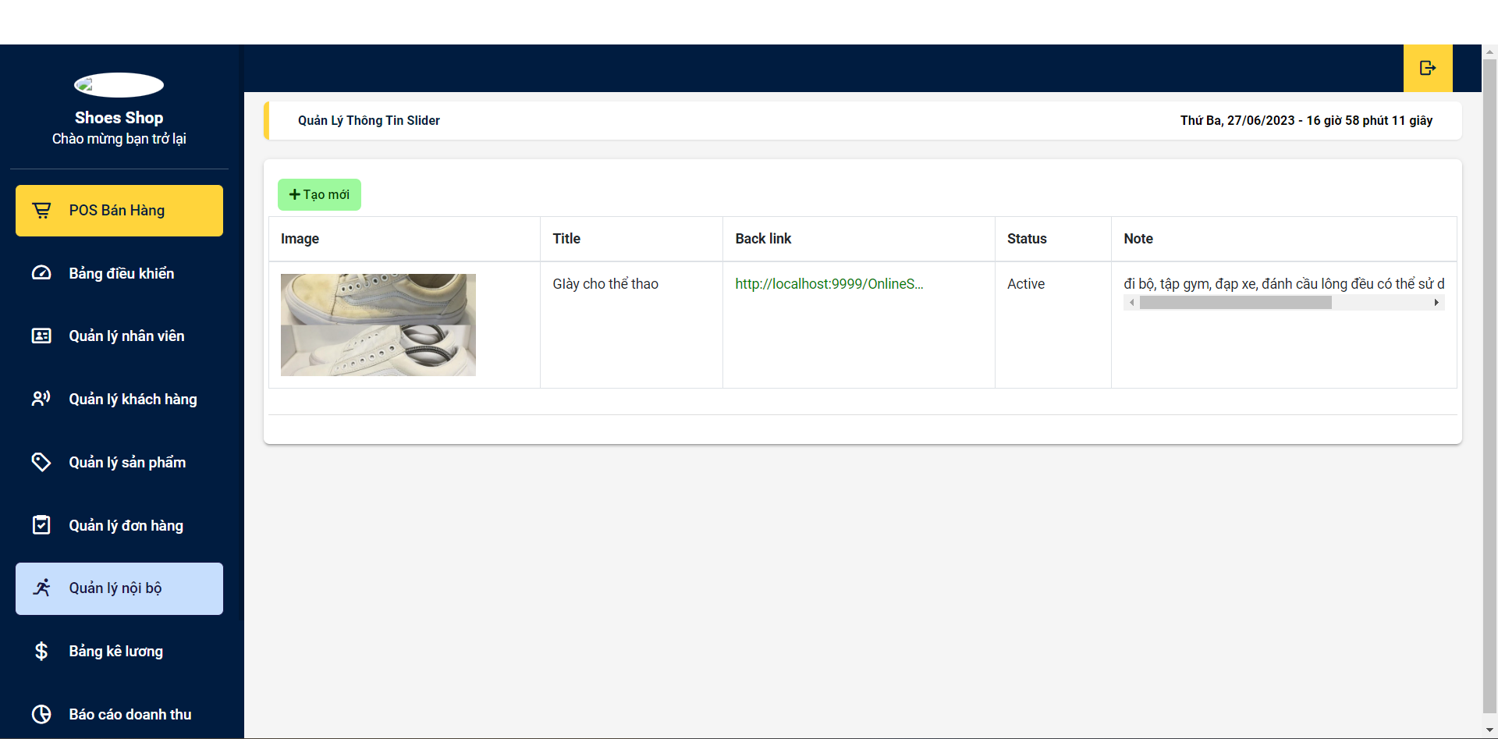

- Function Details:Show detailed slider information (image, title, backlink, status, notes). And go back to the detail list page so that the user can continue other operations.

- Business Logic:

+ Allow users to see detailed details of each slider, thereby making it more convenient to manage.

## 2.15 Slider Detail

**Function Trigger:**

- Triggers: : Show order information

**Function Description:**

- Explanation: Show all orderdetail by order ID.

- Actors/Roles:

+ User: Individuals who do not have an account and want to seen order detail by order

- Purpose: To help people seen order information to be able to buy in the website

- Interface: This page shows a list of order when users click on a “view” in the order. Users can filter their list order information by id they want to buy based, and can update the list through the “update” button.

**Screen Layout:**

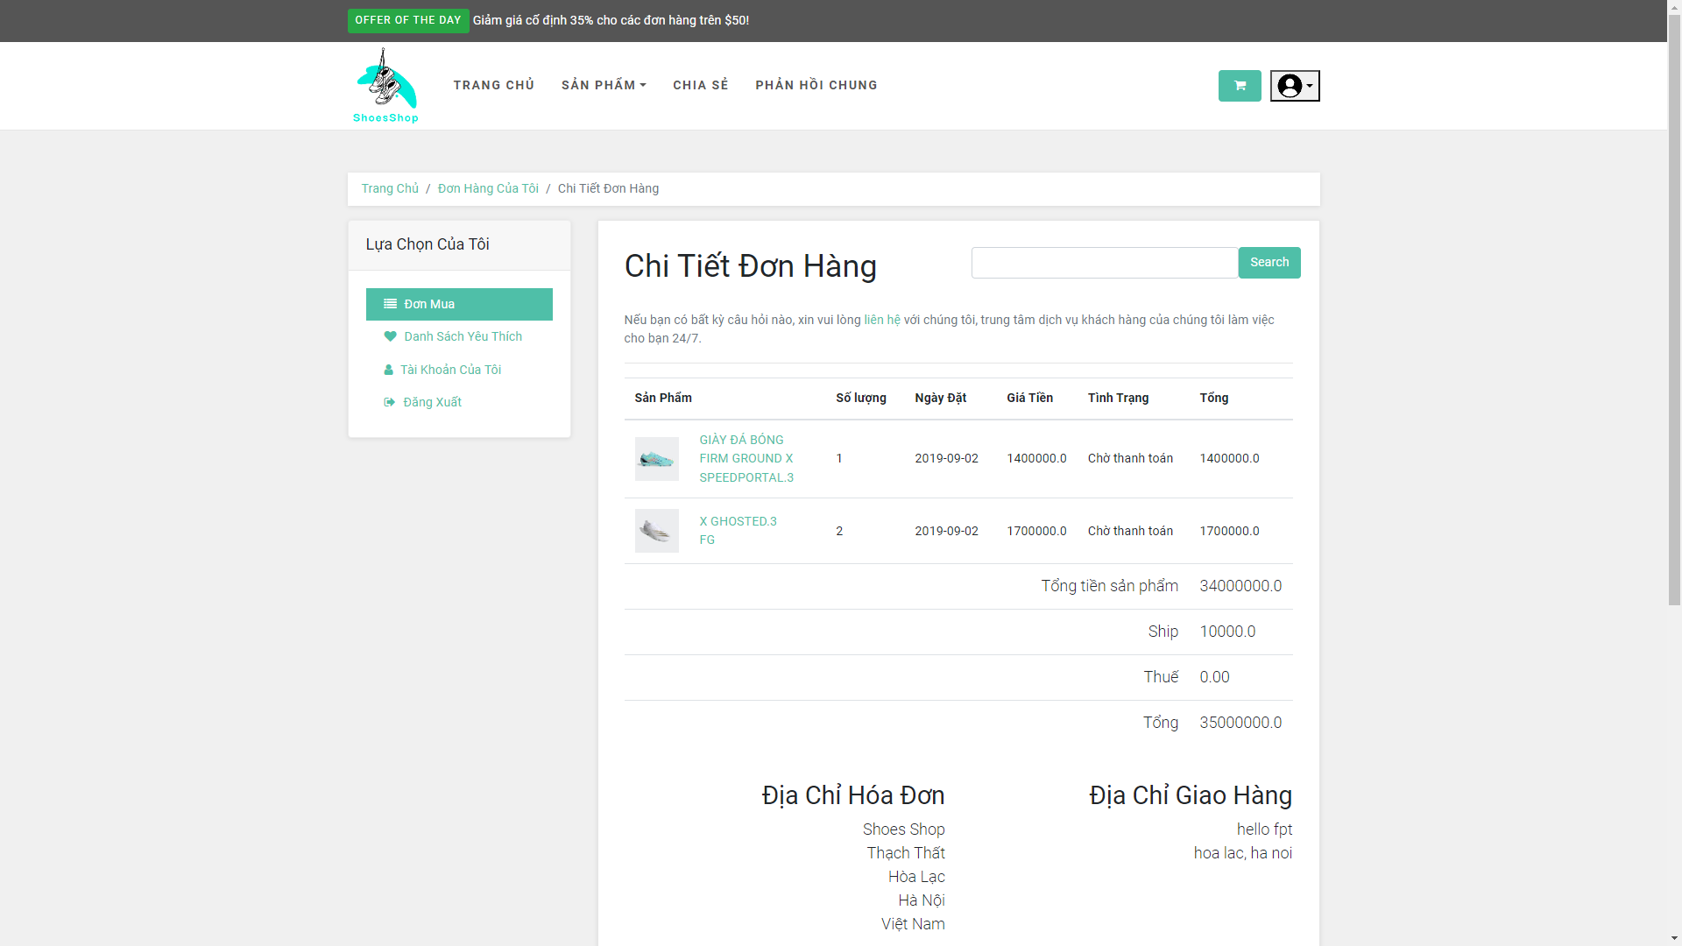

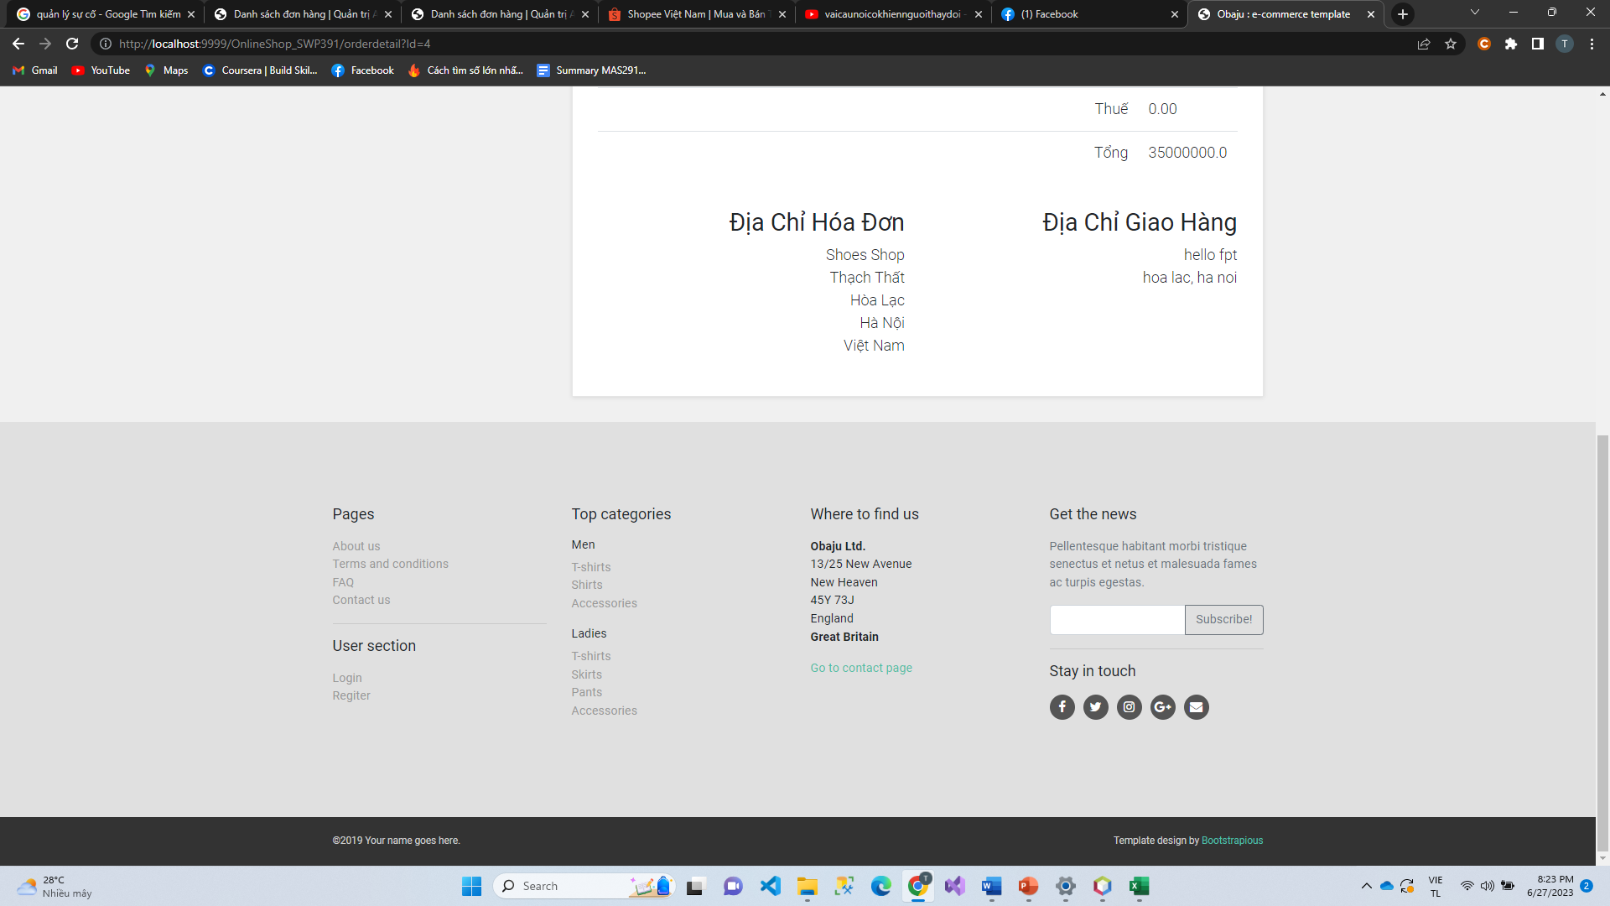

**Function Details:**

- Data Validation: When users find all the information , our system will show their information and multiple choice to user can search update feedback and re-buy.

- Normal Case Functionality:

+ Show list order for user.

+ Search order by name.

+ Feedback product if you summited order.

+ For the submitted orders, the user can choose to update (redirect the user to the Cart Details page for that) or cancel the order.

## 2.16 Cart Details

**Function Trigger:**

- Trigger: Save to the cart that the customer has selected

- Navigation Path: Access the shopping cart through the shopping cart above the website header.

**Function Description:**

- Explanation: Show the cart details with list of the user's chosen products (including Id, title, price, quantity, total cost) and the total order price, the product search box.The user can:

+ Change the quantity of each product: the total cost is automatically adjusted

+ Choose to delete/remove product by clicking on the deleting icon

+ Click the Choose More Product button to go to Products List page

+ Click the Check Out button to go to the Cart Contact page

- Actors/Roles: Customer

- Purpose: Save the product that the user has selected to proceed to the checkout step.

- Interface: Show the cart details with list of the user's chosen products

**Screen Layout:**

Do not let the sider display the category product because you want to take advantage of the display area for the cart detail

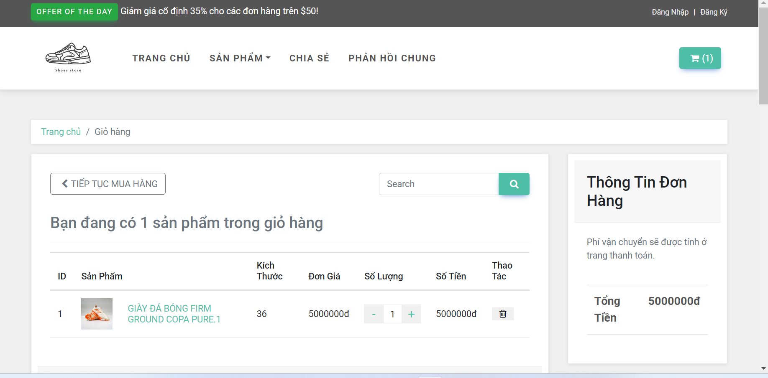

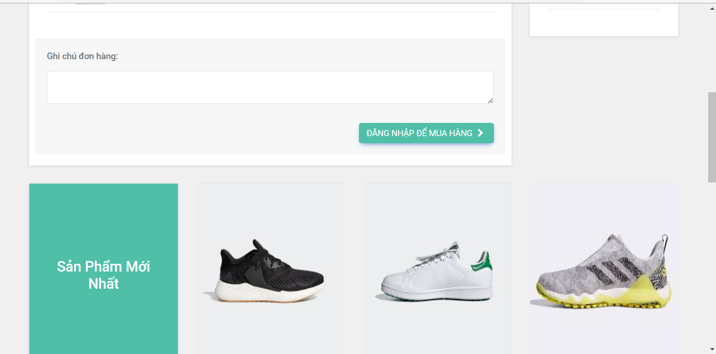

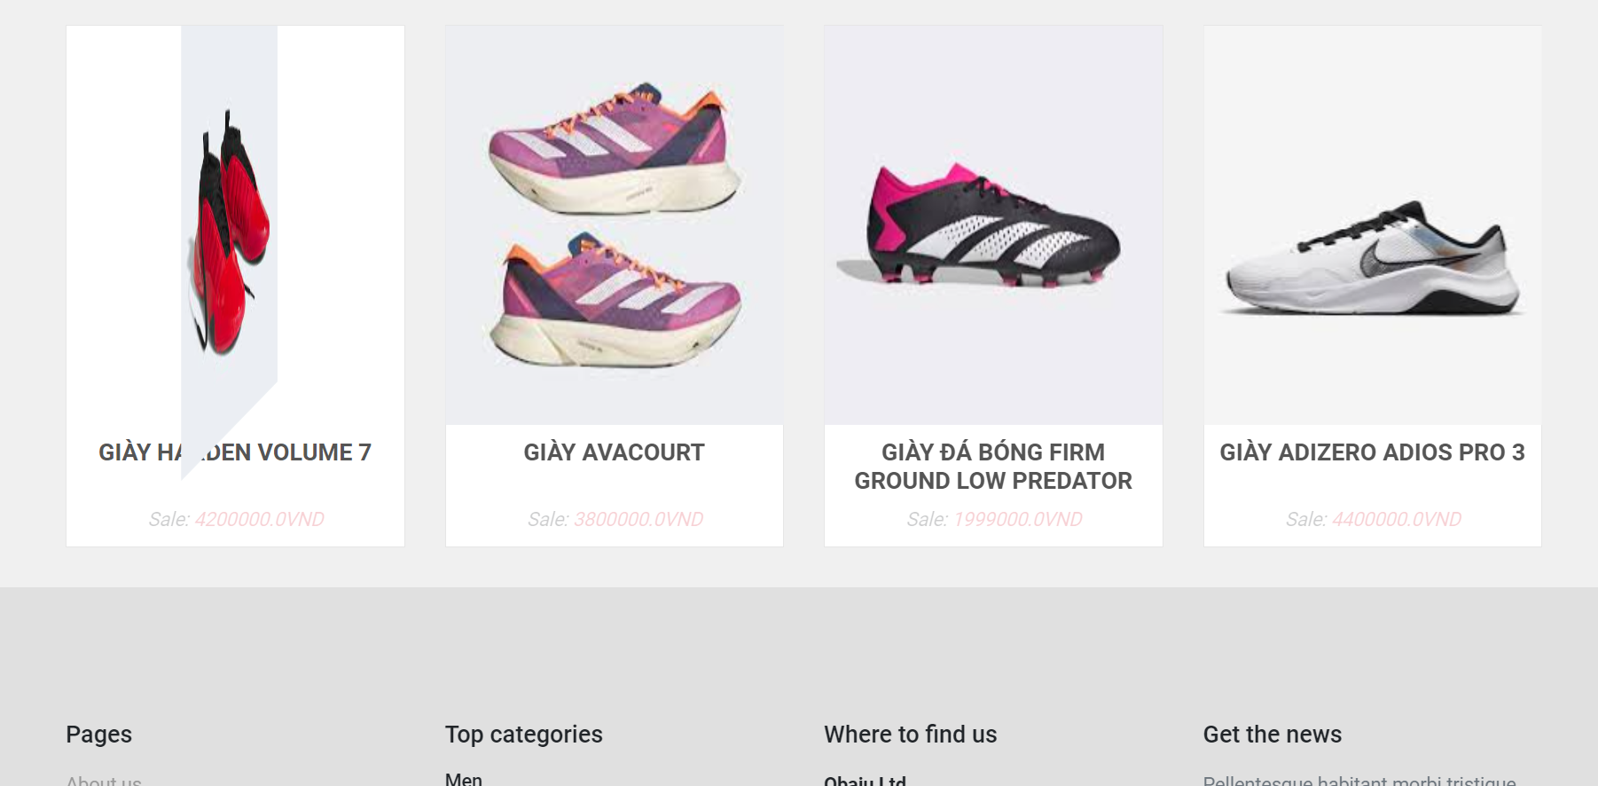

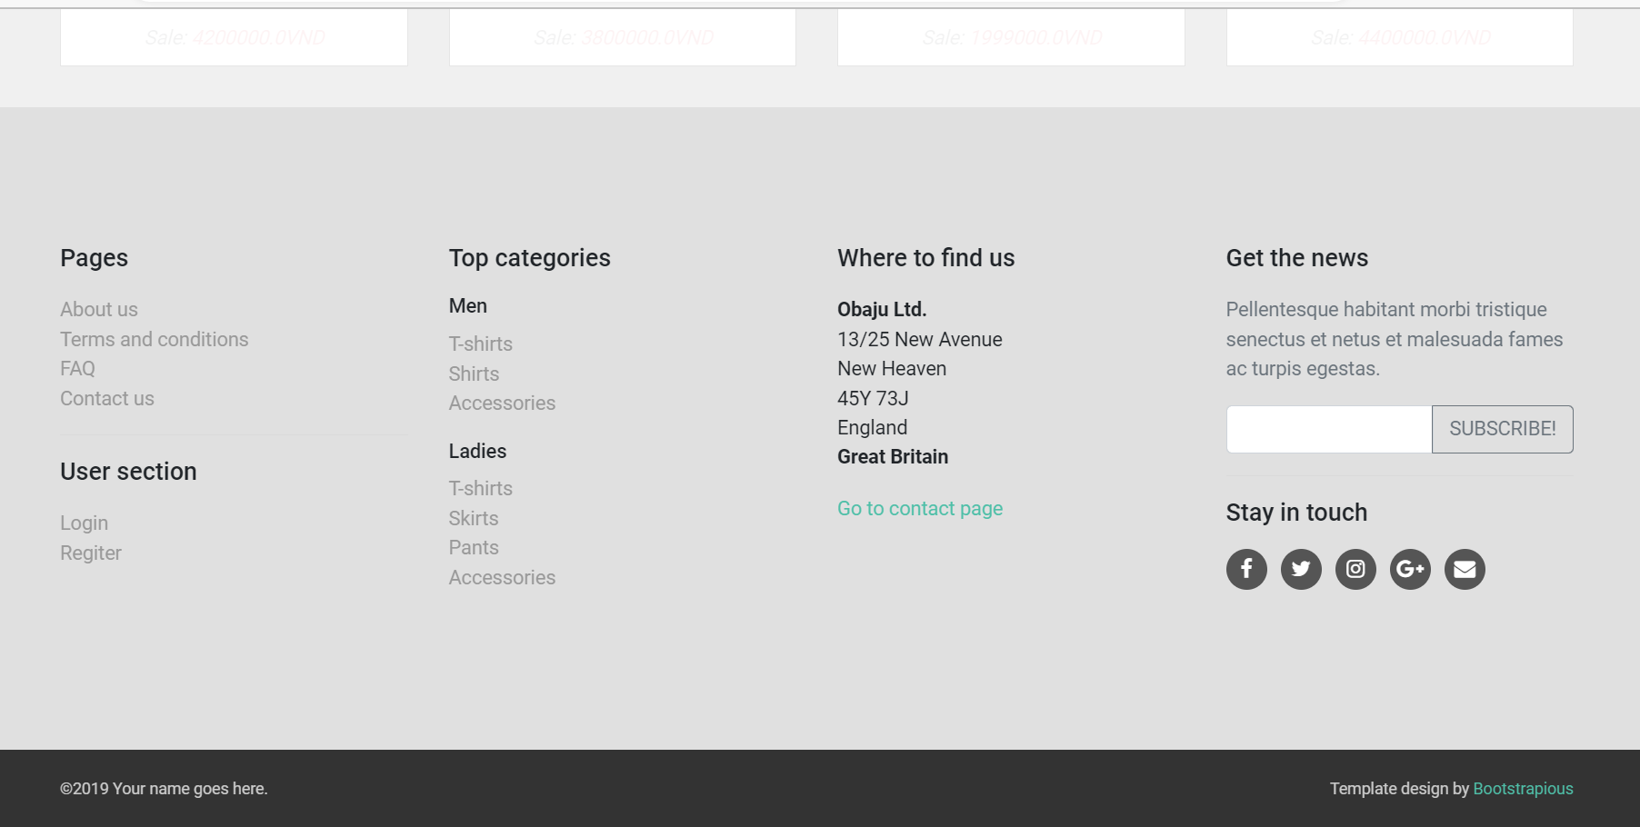

**Function Details:**

- Show the cart details with list of the user's chosen products (including Id, title, price, quantity, total cost) and the total order price, the product search box

- Data Validation:

+ Check the validity of URLs of the slider list to ensure that users can access related pages.

+ Check if the user is logged in to the site.

- Data Processing: When the user selects a product, the data will be transmitted to the servlet and processed, then it will be pushed to the link containing the interface of the shopping cart for the user to see and check the product information he has just selected is correct.

- Business Logic: Users are not allowed to buy more than the number of products currently in stock

- Normal Case Functionality:

+ Change the quantity of each product: the total cost is automatically adjusted

+ Choose to delete/remove product by clicking on the deleting icon

+ Click the Choose More Product button to go to Products List page

+ Click the Check Out button to go to the Cart Contact page

## 2.17 Cart Contact

**Function Trigger:**

- Trigger: Display the product details the user has selected, and the shipping address information, select the shipping method.

- Navigation Path: After the user reconfirms the selected product in the cart detail, the user chooses to purchase. The website will take the user to the contact cart to collect user information for the delivery of the product to their hands.

**Function Description:**

- Explanation: Show the list of user chosen product (including id, title, price, quantity, total cost), the total order price and the receiver information (including full-name, gender, email, mobile, address, notes) for user to edit/input

- Actors/Roles: Customers

- Purpose: Verify the product the user chooses and get the user's shipping information

- Interface: Show the list of user chosen product (including id, title, price, quantity, total cost), the total order price and the receiver information (including full-name, gender, email, mobile, address, notes)

**Screen Layout:**

Do not let the sider display the category product because you want to take advantage of the display area for the cart contact

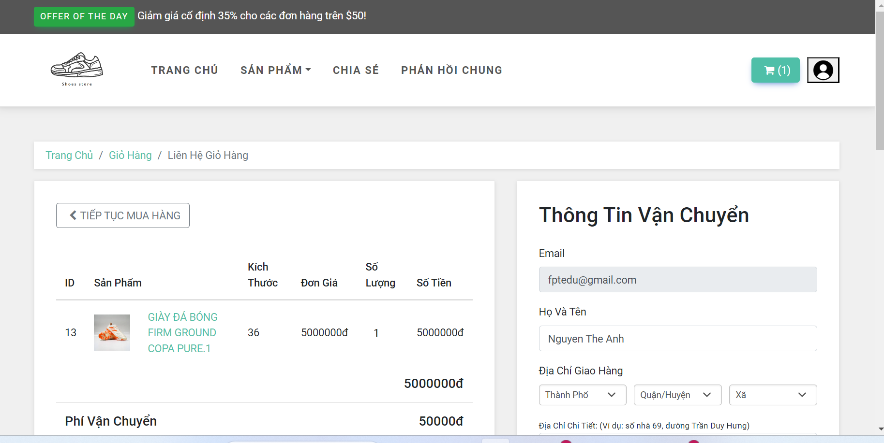

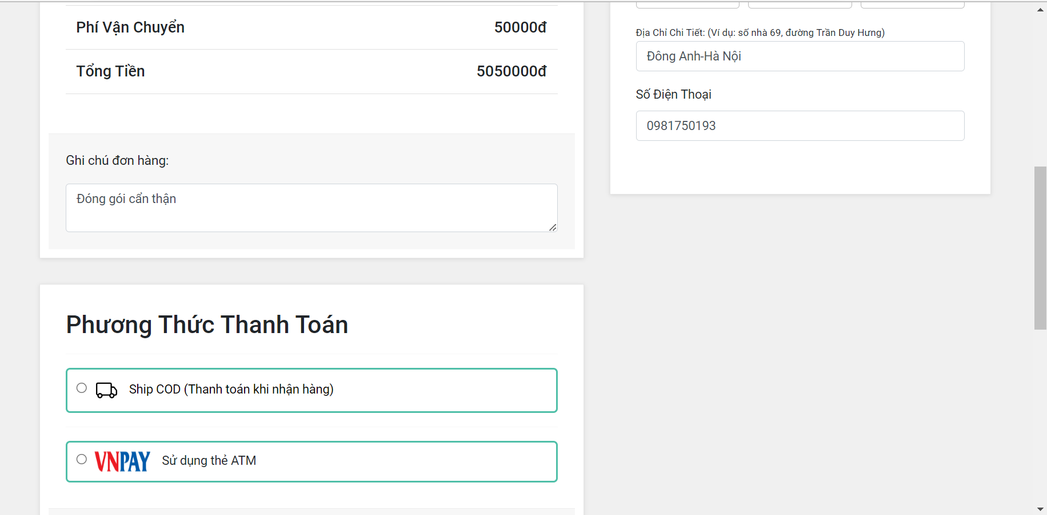

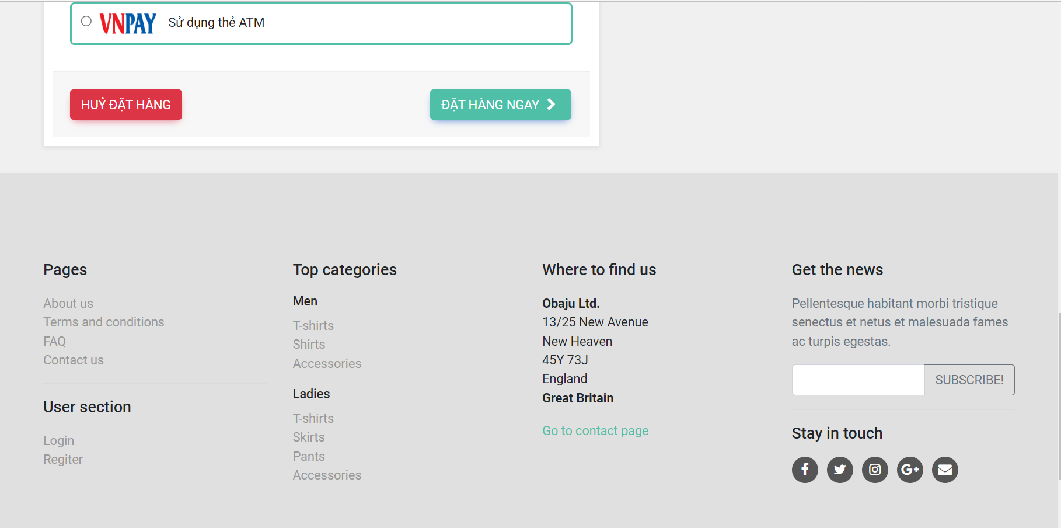

**Function Details:**

- Show the list of user chosen product (including id, title, price, quantity, total cost), the total order price and the receiver information (including full-name, gender, email, mobile, address, notes) for user to edit/input

- In case the user has logged in, the receiver information would be filled with the user's information

- The user can click the Change button to come back to the Cart Details page for changing the choosing products, click the Submit button to submit the order before redirecting user to the Card Completion or Error page (due to technical error or any out-of-stock product)

- Data Validation:

+ Check if the URL is correct

+ Check if the user's travel information is available

- Business Logic: Address, user information must be valid.

- Normal Case Functionality:

+ User fills in shipping information, chooses payment method for order.